DATA ENGINEERING JOURNAL

NAME: Insiya Shoeb Bobde

STUDENT ID: 5115304

ROLL NO: 06

SUBJECT: Data Engineering

Data Engineering Practicals
Practical-1
Q.no.1-Write programs to parse text files ,CSV,Html, XML and JSON documents and extract relevant data .After retrieving data check any anomalies in the data, missing values etc.

Aim: To write Python programs to parse and extract relevant data from Text, CSV, HTML, XML, and JSON files, and to identify anomalies such as missing values, duplicate records, invalid values, and inconsistent data.

Code:

import pandas as pd

import json

import xml.etree.ElementTree as ET

from bs4 import BeautifulSoup

import re

import os

# Common function to check data for anomalies

def check_anomalies(df, name="Data"):

print(f"\n{'=' * 60}")

print(f"ANOMALY CHECK: {name}")

print(f"{'=' * 60}")

# Missing values

print("\n1. Missing Values:")

missing = df.isnull().sum()

if missing.sum() == 0:

print("No missing values found.")

else:

print(missing[missing > 0])

# Duplicate rows

print("\n2. Duplicate Records:")

duplicates = df.duplicated().sum()

print("Number of duplicate records:", duplicates)

# Empty strings

print("\n3. Empty String Values:")

empty_values = (df.astype(str).apply(lambda x: x.str.strip() == "").sum())

if empty_values.sum() == 0:

print("No empty string values found.")

else:

print(empty_values[empty_values > 0])

# Numeric columns - negative values

print("\n4. Negative Numeric Values:")

numeric_columns = df.select_dtypes(include="number").columns

for column in numeric_columns:

negative = (df[column] < 0).sum()

if negative > 0:

print(f"{column}: {negative} negative values")

# Display summary

print("\n5. Data Summary:")

print(df.describe(include="all"))

# ---------------------------------------------------------

# 1. Parse TEXT file

# ---------------------------------------------------------

def parse_text_file(filename):

print("\n\n===== TEXT FILE =====")

records = []

with open(filename, "r", encoding="utf-8") as file:

for line_number, line in enumerate(file, start=1):

line = line.strip()

if not line:

continue

# Example format:

# Name: John, Age: 25, City: Mumbai

fields = {}

for item in line.split(","):

if ":" in item:

key, value = item.split(":", 1)

fields[key.strip()] = value.strip()

if fields:

records.append(fields)

df = pd.DataFrame(records)

print("\nExtracted Data:")

print(df)

check_anomalies(df, "Text File")

return df

# ---------------------------------------------------------

# 2. Parse CSV file

# ---------------------------------------------------------

def parse_csv_file(filename):

print("\n\n===== CSV FILE =====")

try:

df = pd.read_csv(filename)

print("\nExtracted Data:")

print(df)

check_anomalies(df, "CSV File")

return df

except Exception as e:

print("Error reading CSV:", e)

return None

# ---------------------------------------------------------

# 3. Parse HTML file

# ---------------------------------------------------------

def parse_html_file(filename):

print("\n\n===== HTML FILE =====")

with open(filename, "r", encoding="utf-8") as file:

html = file.read()

soup = BeautifulSoup(html, "html.parser")

records = []

# Extract HTML tables

tables = soup.find_all("table")

for table in tables:

rows = table.find_all("tr")

headers = []

for row_index, row in enumerate(rows):

cells = row.find_all(["th", "td"])

values = [cell.get_text(strip=True) for cell in cells]

if row_index == 0:

headers = values

else:

if values:

if headers and len(values) == len(headers):

records.append(dict(zip(headers, values)))

if records:

df = pd.DataFrame(records)

print("\nExtracted Data:")

print(df)

check_anomalies(df, "HTML File")

return df

print("No table data found in HTML file.")

return None

Output:

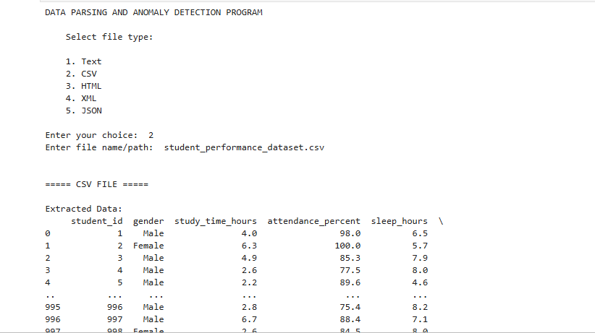

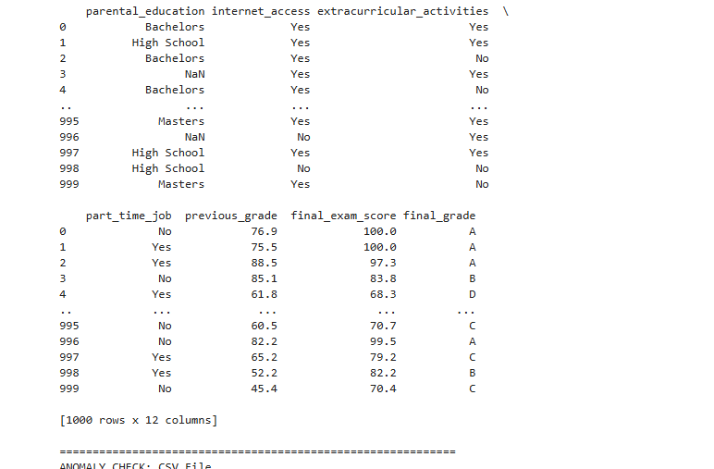

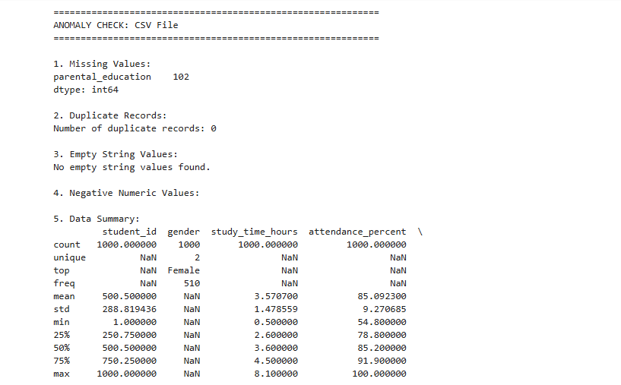

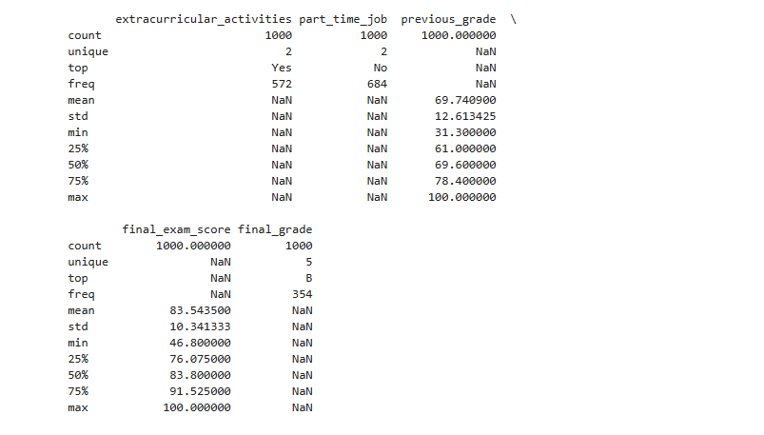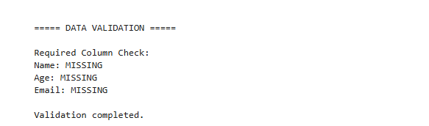

Q.no.2-Write programs for reading and writing binary files.

Aim:To write Python programs for reading data from and writing data to binary files using file handling operations.

Program: Read and Write a Binary File

# Writing data to a binary file

data = b"Hello, this is binary file data."

with open("sample.bin", "wb") as file:

file.write(data)

print("Data written successfully.")

# Reading data from the binary file

with open("sample.bin", "rb") as file:

data = file.read()

print("Data read from binary file:")

print(data)

# Convert bytes to string

print("Decoded data:")

print(data.decode())

Output:

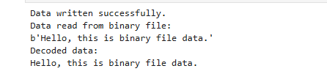

Q.no.3- Write prog for searching ,splitting , and replacing strings based on pattern matching using regular expression

Aim
To write a Python program for searching, splitting, and replacing strings based on pattern matching using regular expressions.

Program

import re

text = "My email is john@gmail.com and my phone number is 9876543210."

# 1. Searching using regular expression

pattern = r"\b[\w.-]+@[\w.-]+\.\w+\b"

match = re.search(pattern, text)

if match:

print("Email found:", match.group())

else:

print("Email not found")

# 2. Splitting using regular expression

sentence = "Python,Java;C++:HTML"

result = re.split(r"[,;:]", sentence)

print("\nAfter splitting:")

print(result)

# 3. Replacing using regular expression

new_text = re.sub(r"\d", "*", text)

print("\nAfter replacing digits:")

print(new_text)

# ---------------------------------------------------------

# 4. Parse XML file

# ---------------------------------------------------------

def parse_xml_file(filename):

print("\n\n===== XML FILE =====")

tree = ET.parse(filename)

root = tree.getroot()

records = []

# Assumes XML contains repeated child elements such as:

# <students>

# <name>John</name>

# <age>20</age>

# </student>

# </students>

for item in root:

record = {}

for child in item:

record[child.tag] = child.text

if record:

records.append(record)

df = pd.DataFrame(records)

print("\nExtracted Data:")

print(df)

check_anomalies(df, "XML File")

return df

# ---------------------------------------------------------

# 5. Parse JSON file

# ---------------------------------------------------------

def parse_json_file(filename):

print("\n\n===== JSON FILE =====")

with open(filename, "r", encoding="utf-8") as file:

data = json.load(file)

# JSON may contain either:

# [

# {"name": "John", "age": 20},

# {"name": "Alice", "age": 22}

# ]

#

# or:

# {"students": [...]}

if isinstance(data, dict):

# Find the first list inside the JSON object

list_data = None

for value in data.values():

if isinstance(value, list):

list_data = value

break

if list_data is not None:

data = list_data

else:

data = [data]

df = pd.json_normalize(data)

print("\nExtracted Data:")

print(df)

check_anomalies(df, "JSON File")

return df

# ---------------------------------------------------------

# Additional validation

# ---------------------------------------------------------

def validate_data(df):

print("\n\n===== DATA VALIDATION =====")

# Check required columns

required_columns = ["Name", "Age", "Email"]

print("\nRequired Column Check:")

for column in required_columns:

if column in df.columns:

print(f"{column}: Found")

else:

print(f"{column}: MISSING")

# Check email format

if "Email" in df.columns:

print("\nInvalid Email Addresses:")

email_pattern = r"^[\w\.-]+@[\w\.-]+\.\w+$"

for index, email in df["Email"].items():

if pd.notna(email):

if not re.match(email_pattern, str(email)):

print(f"Row {index}: {email}")

# Check age

if "Age" in df.columns:

print("\nInvalid Age Values:")

for index, age in df["Age"].items():

try:

age = float(age)

if age < 0 or age > 120:

print(f"Row {index}: Invalid age = {age}")

except (ValueError, TypeError):

print(f"Row {index}: Non-numeric age = {age}")

print("\nValidation completed.")

# ---------------------------------------------------------

# Main program

def main():

print("DATA PARSING AND ANOMALY DETECTION PROGRAM")

print("""

Select file type:

1. Text 2. CSV 3. HTML 4. XML 5. JSON

""")

choice = input("Enter your choice: ")

filename = input("Enter file name/path: ")

if not os.path.exists(filename):

print("File does not exist.")

return

if choice == "1":

df = parse_text_file(filename)

elif choice == "2":

df = parse_csv_file(filename)

elif choice == "3":

df = parse_html_file(filename)

elif choice == "4":

df = parse_xml_file(filename)

elif choice == "5":

df = parse_json_file(filename)

else:

print("Invalid choice.")

return

if df is not None and not df.empty:

validate_data(df)

if __name__ == "__main__":

main()
Output:
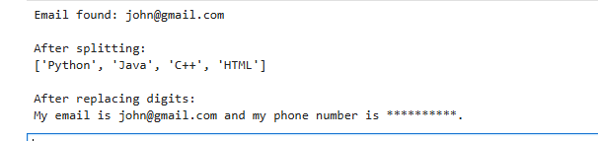
Q.no.4- Design a relational database for a small app and populate the database. Using sql do the CRUD (create , read, updated and delete) operation.

Aim: To design and implement a relational database for a small application, populate it with sample records, and perform CRUD operations (Create, Read, Update, Delete) using SQL.

Example: College Management
-- ==========================================
-- 1. CREATE DATABASE
-- ==========================================
CREATE DATABASE CollegeManagement;
GO
-- Select the database
USE CollegeManagement;
GO
-- ==========================================
-- 2. CREATE TABLE
-- ==========================================
CREATE TABLE Students
(
student_id INT IDENTITY(1,1) PRIMARY KEY,
name VARCHAR(100) NOT NULL,
email VARCHAR(100) UNIQUE,
course VARCHAR(100),
age INT,
city VARCHAR(50)
);
GO
-- ==========================================
-- 3. POPULATE DATABASE
-- ==========================================
INSERT INTO Students (name, email, course, age, city)
VALUES
('Aarav Sharma', 'aarav@gmail.com', 'Data Science', 20, 'Mumbai'),
('Priya Patil', 'priya@gmail.com', 'Computer Science', 21, 'Pune'),
('Rahul Verma', 'rahul@gmail.com', 'Information Technology', 20, 'Delhi'),
('Sneha Joshi', 'sneha@gmail.com', 'Data Science', 22, 'Nashik'),
('Aditya Shah', 'aditya@gmail.com', 'Artificial Intelligence', 21, 'Mumbai');
GO
-- ==========================================
-- 4. CREATE OPERATION
-- Add a new student
-- ==========================================
INSERT INTO Students (name, email, course, age, city)
VALUES
('Neha Kulkarni', 'neha@gmail.com', 'Cyber Security', 20, 'Nagpur');
GO
-- ==========================================
-- 5. READ OPERATION
-- ==========================================
SELECT * FROM Students;
GO
-- Read specific students
SELECT *
FROM Students
WHERE course = 'Data Science';
GO
-- ==========================================
-- 6. UPDATE OPERATION
-- ==========================================
UPDATE Students
SET course = 'Machine Learning'
WHERE student_id = 1;
GO
SELECT * FROM Students;
GO
-- ==========================================
-- 7. DELETE OPERATION
-- ==========================================
DELETE FROM Students
WHERE student_id = 6;
GO
SELECT * FROM Students;
GO
Output:
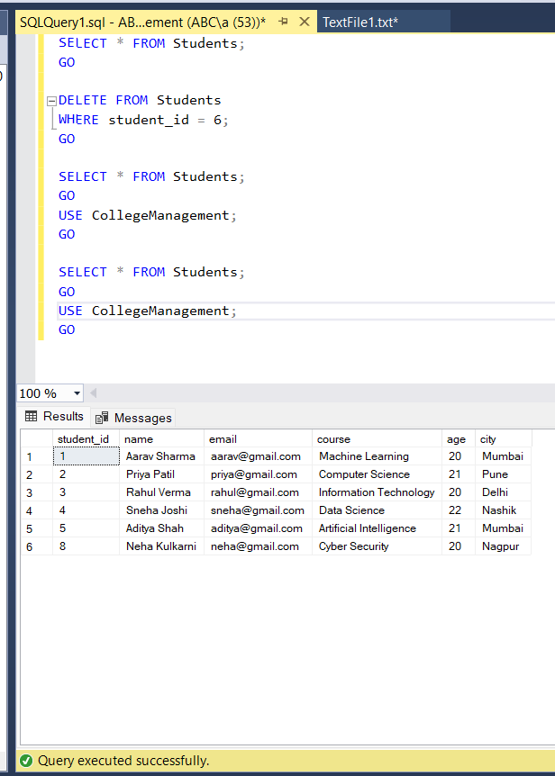
Practical-2

ETL Process Using SQL Server

Aim: To perform the Extraction, Transformation and Loading (ETL) process using SQL Server by creating a database, staging table, transforming data, and loading it into a final table.

Complete SQL Code

Step 1: Create a New Database
CREATE DATABASE BI_ETL_Practical2;
GO

USE BI_ETL_Practical2;
GO

Step 2: Create Staging Table
CREATE TABLE Raw_Product_Data
(
ProductID INT,
ProductName VARCHAR(100),
Category VARCHAR(50),
Quantity INT,
Price DECIMAL(10,2),
SaleDate VARCHAR(20),
City VARCHAR(50)
);
GO

Step 3: Extract / Insert Raw Data
INSERT INTO Raw_Product_Data
(ProductID, ProductName, Category, Quantity, Price, SaleDate, City)
VALUES
(101, 'Laptop', 'Electronics', 2, 55000, '2026-01-10', 'Mumbai'),
(102, 'Mobile', 'Electronics', 3, 25000, '2026-01-12', 'Pune'),
(103, 'Chair', 'Furniture', 5, 4500, '2026-01-15', 'Nashik'),
(104, 'Table', 'Furniture', 2, 8000, '2026-01-18', 'Mumbai'),
(105, 'Headphones', 'Electronics', 4, 2000, '2026-01-20', 'Nagpur');
GO

Step 4: Display Raw Data
SELECT *
FROM Raw_Product_Data;
GO

Step 5: Create Final Table
CREATE TABLE Processed_Product_Data
(
ProductID INT PRIMARY KEY,
ProductName VARCHAR(100),
Category VARCHAR(50),
Quantity INT,
Price DECIMAL(10,2),
SaleDate DATE,
City VARCHAR(50),
TotalAmount DECIMAL(12,2)
);
GO

Step 6: Transform and Load Data
The date is converted from VARCHAR to DATE, and the total amount is calculated.
INSERT INTO Processed_Product_Data
(
ProductID,
ProductName,
Category,
Quantity,
Price,
SaleDate,
City,
TotalAmount
)
SELECT
ProductID,
ProductName,
Category,
Quantity,
Price,
CONVERT(DATE, SaleDate),
City,
Quantity * Price
FROM Raw_Product_Data;
GO

Step 7: Display Final Transformed Data
SELECT *
FROM Processed_Product_Data;
GO

Step 8: Perform Analysis
-- Total Sales
SELECT SUM(TotalAmount) AS Total_Sales
FROM Processed_Product_Data;
GO
-- Category-wise Sales
SELECT
Category,
SUM(TotalAmount) AS Category_Total
FROM Processed_Product_Data
GROUP BY Category;
GO
-- City-wise Sales
SELECT
City,
SUM(TotalAmount) AS City_Total
FROM Processed_Product_Data
GROUP BY City;
GO

ETL Process
Raw Product Data
↓
Extraction
↓
Raw_Product_Data
↓
Transformation
↓
Date Conversion
Quantity × Price
↓
Processed_Product_Data
↓
Analysis

Output:

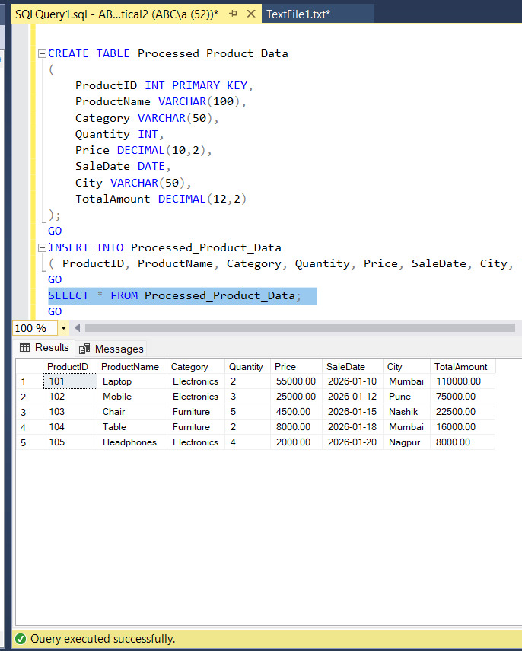
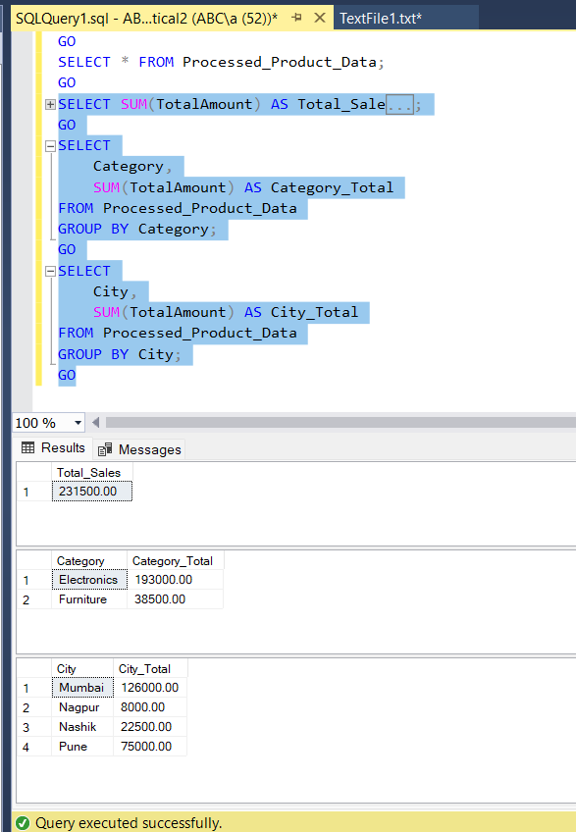

Result
The ETL process was successfully performed using SQL Server. The raw product data was extracted into a staging table, transformed by converting the date and calculating the total amount, and loaded into the final processed table.

Practical-3
MongoDB Operations

Aim: To perform single and multiple document insertion and retrieval using MongoDB shell (mongosh).

Software/Tools Required
- MongoDB
- MongoDB Shell (mongosh)
- Command Prompt / Terminal

Theory
MongoDB is a NoSQL, document-oriented database that stores data in the form of JSON-like documents. In MongoDB, documents are stored inside collections.
The main operations performed in this practical are:
- Inserting a single document
- Retrieving documents
- Inserting multiple documents
- Displaying documents in formatted JSON

Procedure

Step 1: Insert a Single Document
Query:
db.items.insertOne({
name: "laptop",
price: 999
});

Step 2: View the Inserted Document
Query:
db.items.find();

Step 3: Insert Multiple Documents
Query:
db.products.insertMany([
{
name: "phone",
price: 500,
stock: 10
},
{
name: "tablet",
price: 300,
stock: 5
},
{
name: "watch",
price: 150,
stock: 0
}
]);

Step 4: View Products in Formatted JSON
Query:
db.products.find().pretty();
Output:

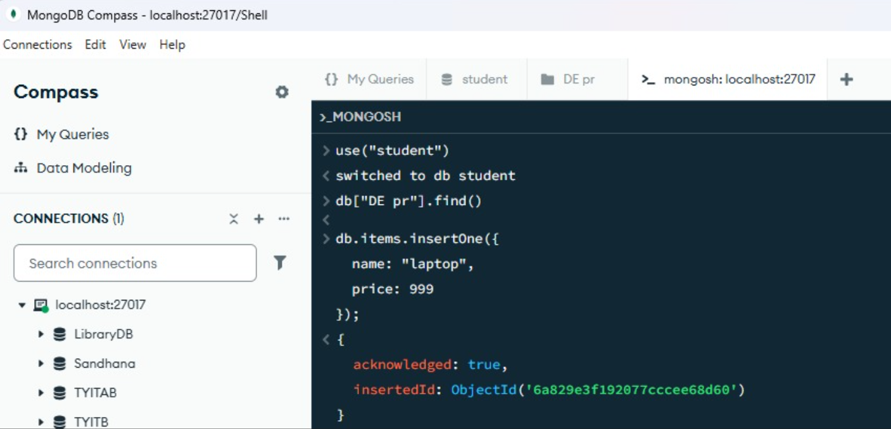

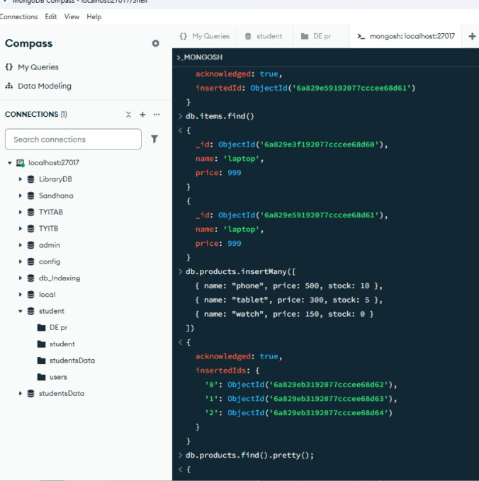
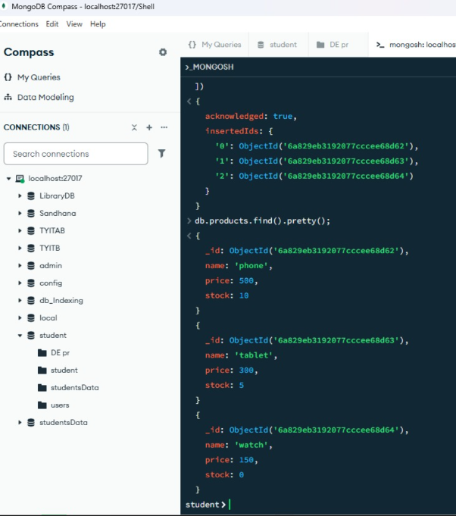

Result
Thus, single and multiple documents were successfully inserted and retrieved using MongoDB mongosh. The inserted documents were also displayed in formatted JSON format.

Conclusion
MongoDB provides simple commands such as insertOne(), insertMany(), find(), and find().pretty() for performing basic document insertion and retrieval operations.
Practical : 4
QUE: Python program demonstrating Noise Elimination, Feature Selection, and Exploratory Data Analysis (EDA) using Pandas, NumPy, Matplotlib, and Scikit-learn
# ==========================================
# Code
import pandas as pd
data = { 'Age': [20, 21, 22, 23, 24, 100],
'Marks': [75, 80, 85, 90, 95, 20],
'Attendance': [85, 88, 90, 92, 94, 50],
'Constant': [1, 1, 1, 1, 1, 1]}
df = pd.DataFrame(data)
print("Original Dataset:")
print(df)
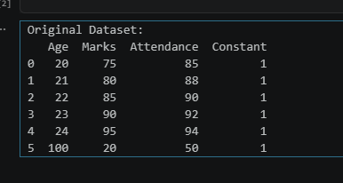
Q1 = df['Age'].quantile(0.25)
Q3 = df['Age'].quantile(0.75)
IQR = Q3 - Q1
lower = Q1 - 1.5 * IQR
upper = Q3 + 1.5 * IQR
df_clean = df[(df['Age'] >= lower) & (df['Age'] <= upper)]
print("\nDataset after Noise Elimination:")
print(df_clean)
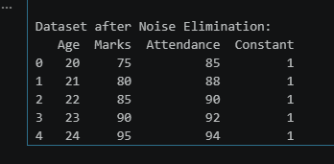
from sklearn.feature_selection import VarianceThreshold
selector = VarianceThreshold(threshold=0.0)
selected = selector.fit_transform(df_clean)
selected_columns = df_clean.columns[selector.get_support()]
print("Selected columns:")
print(selected_columns)
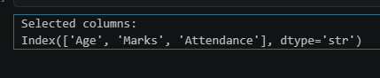
print("\nDataset Information:")
print(df_clean.info())
print("\nStatistical Summary:")
print(df_clean.describe())
print("\nCorrelation Matrix:")
print(df_clean.corr())
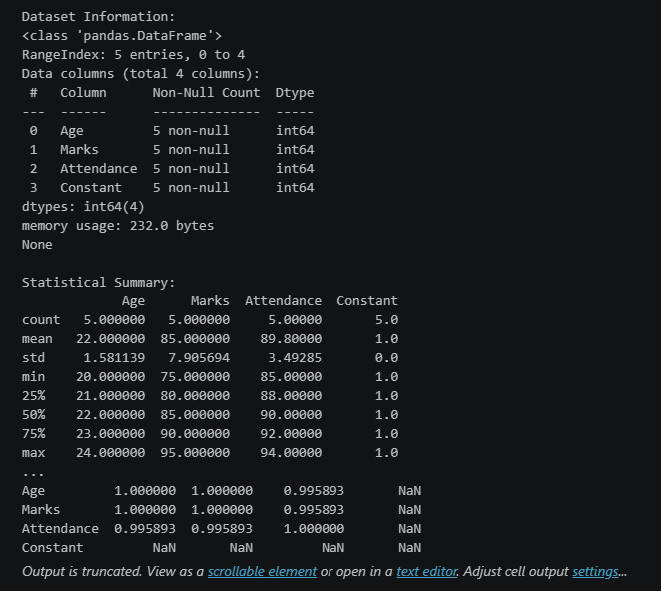
import matplotlib.pyplot as plt
df_clean.hist(figsize=(8, 6))
plt.suptitle("Histogram of Features")
plt.show()
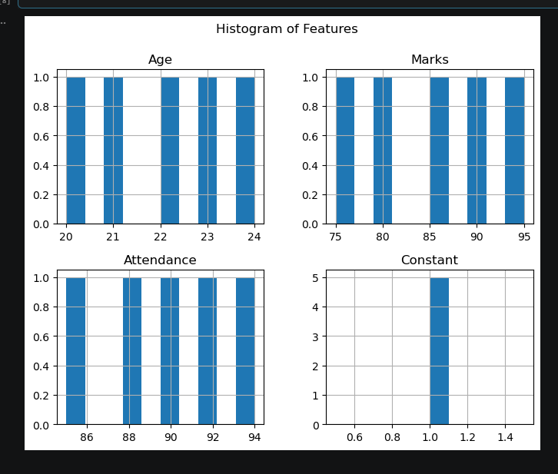

df_clean.boxplot(figsize=(8,5))
plt.title("Boxplot of Dataset")
plt.show()
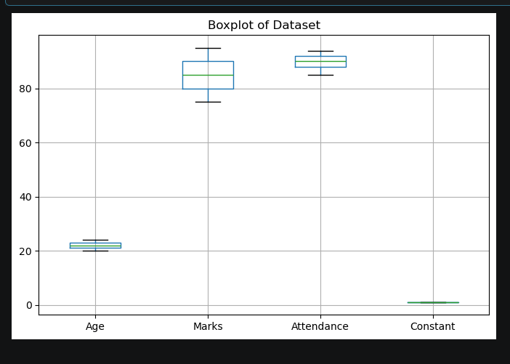

Practical : 5
Que: Extracting Data from APIs and Flat Files Using Python1. ObjectiveWrite a Python script to fetch user data from a public REST API, clean it, and merge it with a flat CSV file containing location details.2. Code ImplementationCreate a script named data_extraction.py:pythonimport pandas as pd
import requests
# ==========================================
# DE PRACTICAL - 5
# ETL Pipeline using API and CSV
# ==========================================
import pandas as pd
import requests
# ------------------------------------------
# 1. Extract data from API
# ------------------------------------------
def extract_api_data(url):
try:
response = requests.get(url, timeout=10)
response.raise_for_status()
data = response.json()
return pd.json_normalize(data)
except requests.exceptions.RequestException as e:
print(f"API Error: {e}")
return pd.DataFrame()
# ------------------------------------------
# 2. Extract data from CSV
# ------------------------------------------
def extract_csv_data(file_path):
try:
return pd.read_csv(file_path)

except FileNotFoundError as e:
print(f"File Error: {e}")
return pd.DataFrame()
# ------------------------------------------
# 3. Get API data
# ------------------------------------------
api_url = "https://jsonplaceholder.typicode.com/users"
api_df = extract_api_data(api_url)
print("API Data:")
print(api_df.head())
# ------------------------------------------
# 4. Transform API data
# ------------------------------------------
api_df = api_df[[
"id",
"name",
"email",
"company.name"
]]
api_df.rename(
columns={"company.name": "company"},
inplace=True
)
print("\nCleaned API Data:")
print(api_df)
# ------------------------------------------
# 5. Create CSV data
# ------------------------------------------
csv_file = "locations.csv"
location_data = {
"id": [1, 2, 3, 4, 5, 6, 7, 8, 9, 10],
"city": [
"New York",
"London",
"Paris",
"Tokyo",
"Berlin",
"Delhi",
"Sydney",
"Moscow",
"Cairo",
"Beijing"
],

"country": [
"USA",
"UK",
"France",
"Japan",
"Germany",
"India",
"Australia",
"Russia",
"Egypt",
"China"
]
}
pd.DataFrame(location_data).to_csv(
csv_file,
index=False

print("\nlocations.csv created successfully!")
# ------------------------------------------
# 6. Read CSV data
# ------------------------------------------
csv_df = extract_csv_data(csv_file)
print("\nLocation Data:")
print(csv_df)
# ------------------------------------------
# 7. Merge API and CSV data
# ------------------------------------------
merged_df = pd.merge(
api_df,
csv_df,
on="id",
how="inner"
)
print("\n--- Merged ETL Pipeline Data View ---")
print(merged_df)
# ------------------------------------------
# 8. Load final data into CSV
# ------------------------------------------
output_file = "cleaned_warehouse_profiles.csv
merged_df.to_csv(
output_file,
index=False
)
print(
f"\nData successfully saved to '{output_file}'"
)
# 9. Read final warehouse data
final_df = pd.read_csv(output_file)
print("\n--- Final Warehouse Data ---")
print(final_df)
Output:
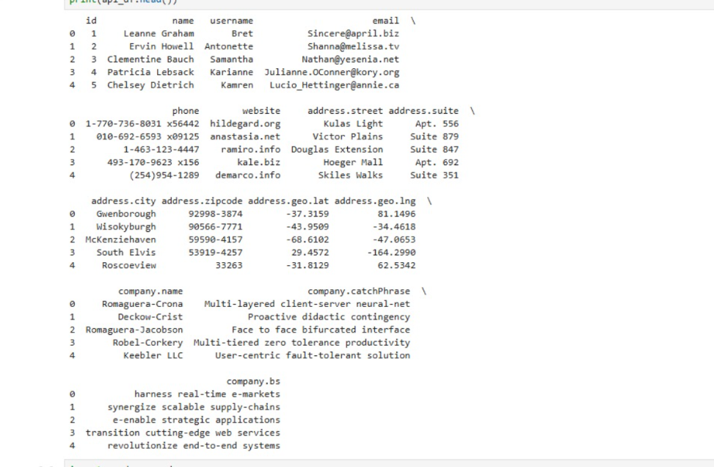
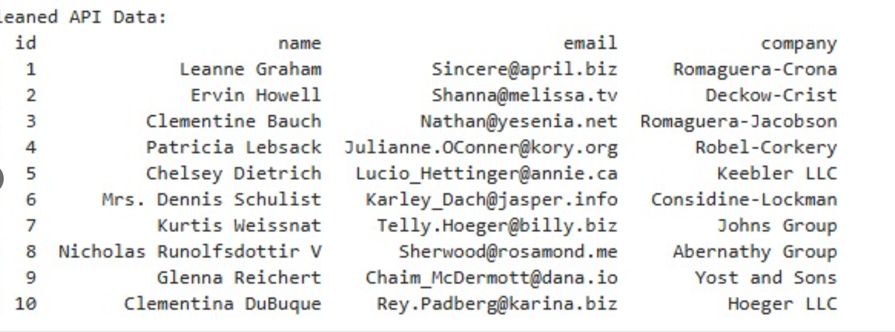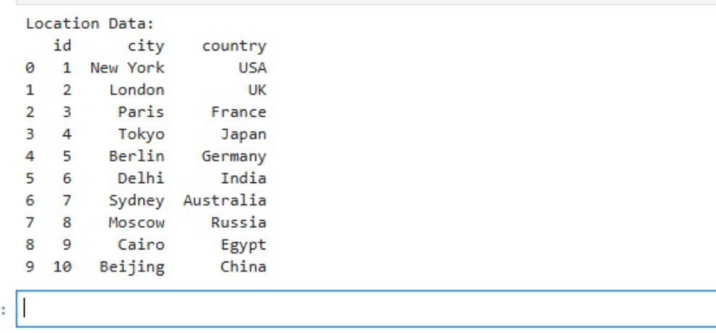
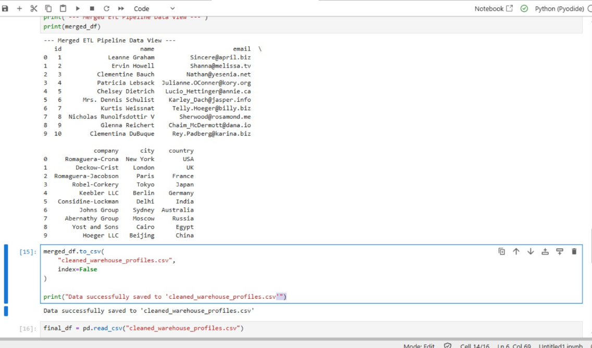
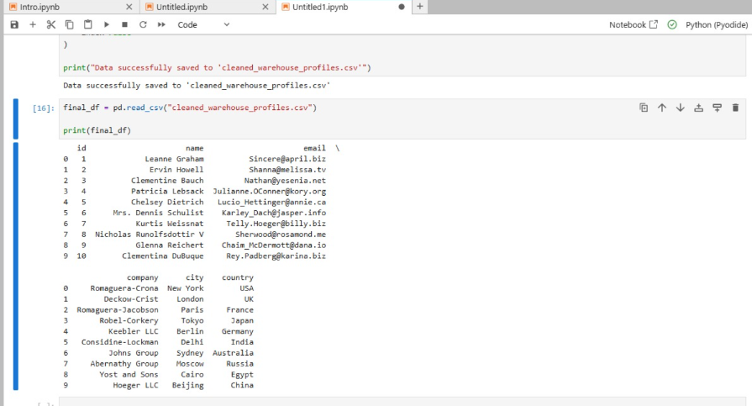
Practical : 6
Que: Setting up Apache Airflow and Creating a DAG1. ObjectiveConfigure a Directed Acyclic Graph (DAG) in Apache Airflow to run daily, executing sequential dependency tasks: a start notifier, an extraction script, and a pipeline success logger.2. DAG ImplementationPlace this code in your Airflow DAGs directory (usually ~/airflow/dags/data_pipeline_dag.py):pythonfrom datetime import datetime, timedelta

Practical-6: Setting Up Apache Airflow and Creating a DAG

Aim
To configure a Directed Acyclic Graph (DAG) in Apache Airflow that runs daily and executes sequential dependency tasks: a start notifier, a data extraction script, and a pipeline success logger.

Requirements
- Python 3
- Apache Airflow
- Linux/Ubuntu or WSL
- Terminal

Procedure
- Install and configure Apache Airflow.
- Create the Airflow dags directory.
- Create a Python extraction script.
- Create the Airflow DAG file.
- Start the Airflow scheduler and web server.
- Trigger the DAG from the Airflow web interface.
- Verify that all tasks execute successfully.

Code
from datetime import datetime, timedelta
from airflow import DAG
from airflow.operators.bash import BashOperator
from airflow.operators.empty import EmptyOperator
from datetime import datetime, timedelta
# Install required packages
!pip install --upgrade pip
!pip install rfc3987 apache-airflow --upgrade
from airflow import DAG
from airflow.operators.bash import BashOperator
from airflow.operators.empty import EmptyOperator

# -------------------------------------------------
# Default arguments for the DAG
# -------------------------------------------------
default_args = {
"owner": "data_engineering_lab",
"depends_on_past": False,
"start_date": datetime(2026, 1, 1),
"email_on_failure": False,
"email_on_retry": False,
"retries": 1,
"retry_delay": timedelta(minutes=5),
}
# -------------------------------------------------
# Define the DAG
# -------------------------------------------------
with DAG(
dag_id="university_etl_orchestration",
default_args=default_args,
description="Daily ETL pipeline orchestration",
schedule=timedelta(days=1),
catchup=False,
) as dag:
# -------------------------------------------------
# Task 1: Start Pipeline
# -------------------------------------------------
start_pipeline = EmptyOperator(
task_id="start_pipeline"
)
# -------------------------------------------------
# Task 2: Run Data Extraction Script
# -------------------------------------------------
execute_extraction = BashOperator(
task_id="run_extraction_script",
bash_command="python3 /home/$USER/airflow/dags/data_extraction.py",
)
# -------------------------------------------------
# Task 3: Log Pipeline Success
# -------------------------------------------------
pipeline_complete = BashOperator(
task_id="log_pipeline_success",
bash_command='echo "ETL Execution completed successfully at $(date)"',
)
# -------------------------------------------------
# Define Task Dependencies
# -------------------------------------------------
start_pipeline >> execute_extraction >> pipeline_complete

Output:
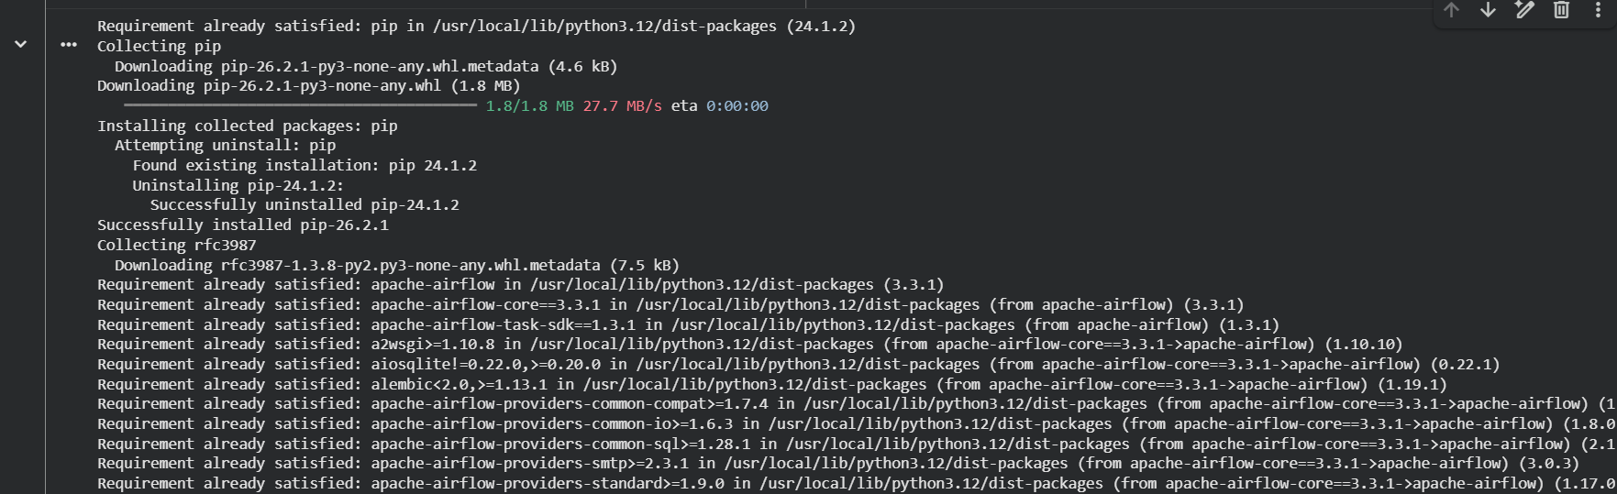
Code:
from datetime import datetime
print("Starting data extraction...")
data = [
{"id": 1, "name": "Student A"},
{"id": 2, "name": "Student B"},
{"id": 3, "name": "Student C"}
]
print("Extracted data:")
for record in data:
print(record)
print("Extraction completed successfully.")
print("Execution time:", datetime.now())

Output:
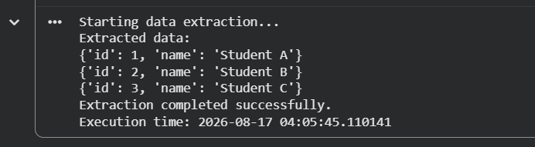
Code:
from datetime import datetime, timedelta
from airflow import DAG
from airflow.operators.bash import BashOperator
from airflow.operators.empty import EmptyOperator
default_args = {
"owner": "data_engineering_lab",
"depends_on_past": False,
"start_date": datetime(2026, 1, 1),
"email_on_failure": False,
"email_on_retry": False,
"retries": 1,
"retry_delay": timedelta(minutes=5),
}
with DAG(
dag_id="university_etl_orchestration",
default_args=default_args,
description="Daily ETL pipeline orchestration",
schedule=timedelta(days=1),
catchup=False,
) as dag:
start_pipeline = EmptyOperator(
task_id="start_pipeline"
)
execute_extraction = BashOperator(
task_id="run_extraction_script",
bash_command="python3 /home/$USER/airflow/dags/data_extraction.py",
)
pipeline_complete = BashOperator(
task_id="log_pipeline_success",
bash_command='echo "ETL Execution completed successfully at $(date)"',
)
start_pipeline >> execute_extraction >> pipeline_complete
Output:
Code:
from datetime import datetime
print("======================================")
print(" DATA EXTRACTION STARTED")
print("======================================")
# Sample data
data = [
{"id": 1, "name": "Student A"},
{"id": 2, "name": "Student B"},
{"id": 3, "name": "Student C"}
]
print("Extracting data...")
for record in data:
print(record)
print("Data extraction completed successfully.")
print("Execution time:", datetime.now())
print("======================================")
print(" DATA EXTRACTION COMPLETED")
print("======================================")
Output:
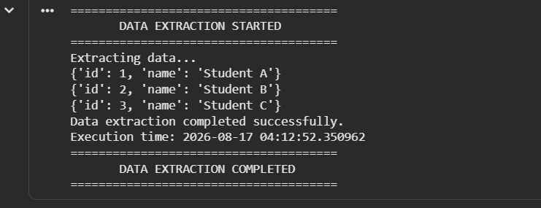

Practical : 7
Que: Design an ETL pipeline to extract data from a CSV file, clean it, transform it, and store it in a database. Extract data from multiple CSV files and combine them into a single dataset. Build a pipeline to extract JSON data, transform selected fields, and load it into a relational database. Design an ETL process to identify and remove invalid records. Create a pipeline that performs data validation before loading data into the target database. Implement incremental data loading instead of loading the entire dataset every time.
Below are 6 ETL practicals with Python code, using Pandas + SQLite. They can be performed in Jupyter Notebook, Google Colab, or VS Code.

Common setup
Install libraries if required:
pip install pandas
SQLite is built into Python, so no separate installation is required.

1: ETL Pipeline from CSV to Database
Aim: Design an ETL pipeline to extract data from a CSV file, clean it, transform it, and store it in a database.
Code:
import pandas as pd
import sqlite3
# -----------------------------
# EXTRACT
# -----------------------------
data = {
"Name": ["Amit", "Priya", "Rahul", "Sneha", "Karan"],
"Age": [21, 22, None, 23, 25],
"City": ["Mumbai", "Pune", "Mumbai", "Delhi", "Pune"],
"Salary": [30000, 35000, 40000, None, 45000]
}
df = pd.DataFrame(data)
df.to_csv("employees.csv", index=False)
# Read CSV file
df = pd.read_csv("employees.csv")
print("Extracted Data:")
print(df)
# -----------------------------
# TRANSFORM / CLEAN
# -----------------------------
# Fill missing Age with mean
df["Age"] = df["Age"].fillna(df["Age"].mean())
# Fill missing Salary with median
df["Salary"] = df["Salary"].fillna(df["Salary"].median())
# Convert Age to integer
df["Age"] = df["Age"].astype(int)
# Remove duplicate records
df = df.drop_duplicates()
# Create Salary Category
df["Salary_Category"] = df["Salary"].apply(
lambda x: "High" if x >= 40000 else "Low"
)
print("\nTransformed Data:")
print(df)
# -----------------------------
# LOAD
# -----------------------------
conn = sqlite3.connect("etl_database.db")
df.to_sql(
"employees",
conn,
if_exists="replace",
index=False
)
print("\nData successfully loaded into database.")
# Verify
result = pd.read_sql("SELECT * FROM employees", conn)
print("\nDatabase Data:")
print(result)
conn.close()

Expected Output

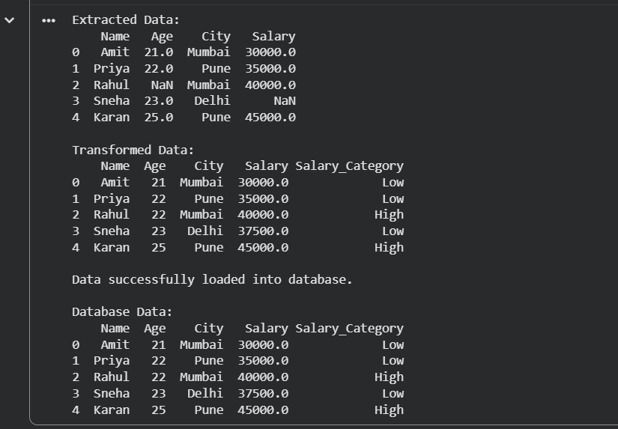

2: Extract Multiple CSV Files and Combine Them
Aim: Extract data from multiple CSV files and combine them into a single dataset.
Code:
import pandas as pd
import sqlite3
# -----------------------------
# CREATE SAMPLE CSV FILES
# -----------------------------
data1 = {
"ID": [1, 2, 3],
"Name": ["Amit", "Priya", "Rahul"],
"Marks": [85, 90, 78]
}
data2 = {
"ID": [4, 5, 6],
"Name": ["Sneha", "Karan", "Neha"],
"Marks": [88, 76, 95]
}
pd.DataFrame(data1).to_csv("students1.csv", index=False)
pd.DataFrame(data2).to_csv("students2.csv", index=False)
# -----------------------------
# EXTRACT
# -----------------------------
df1 = pd.read_csv("students1.csv")
df2 = pd.read_csv("students2.csv")
print("File 1:")
print(df1)
print("\nFile 2:")
print(df2)
# -----------------------------
# TRANSFORM
# -----------------------------
combined_df = pd.concat([df1, df2], ignore_index=True)
# Create result column
combined_df["Result"] = combined_df["Marks"].apply(
lambda x: "Pass" if x >= 40 else "Fail"
)
print("\nCombined Dataset:")
print(combined_df)
# -----------------------------
# LOAD
# -----------------------------
conn = sqlite3.connect("student_database.db")
combined_df.to_sql(
"students",
conn,
if_exists="replace",
index=False
)
print("\nCombined data loaded successfully."
conn.close()

Expected Output

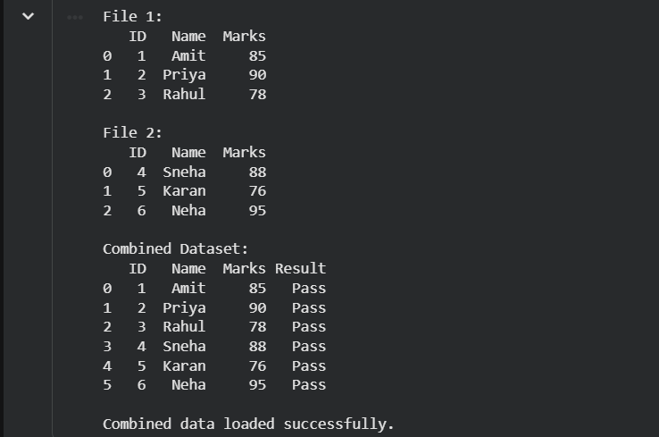

3: ETL Pipeline for JSON Data
Aim: Extract JSON data, transform selected fields, and load it into a relational database.
Code:
import json
import pandas as pd
import sqlite3

# -----------------------------
# CREATE SAMPLE JSON DATA
# -----------------------------

json_data = [
{
"id": 1,
"name": "Amit",
"email": "amit@gmail.com",
"address": {
"city": "Mumbai",
"country": "India"
}
},
{
"id": 2,
"name": "Priya",
"email": "priya@gmail.com",
"address": {
"city": "Pune",
"country": "India"
}
}
]

with open("users.json", "w") as file:
json.dump(json_data, file, indent=4)

# -----------------------------
# EXTRACT
# -----------------------------

with open("users.json", "r") as file:
data = json.load(file)

print("Extracted JSON:")
print(data)

# -----------------------------
# TRANSFORM
# -----------------------------

transformed_data = []

for user in data:
transformed_data.append({
"User_ID": user["id"],
"Name": user["name"].upper(),
"Email": user["email"].lower(),
"City": user["address"]["city"],
"Country": user["address"]["country"]
})

df = pd.DataFrame(transformed_data)

print("\nTransformed Data:")
print(df)

# -----------------------------
# LOAD
# -----------------------------

conn = sqlite3.connect("json_database.db")

df.to_sql(
"users",
conn,
if_exists="replace",
index=False
)

print("\nJSON data loaded into relational database.")

# Verify
result = pd.read_sql("SELECT * FROM users", conn)
print("\nDatabase Table:")
print(result)

conn.close()

Expected Output
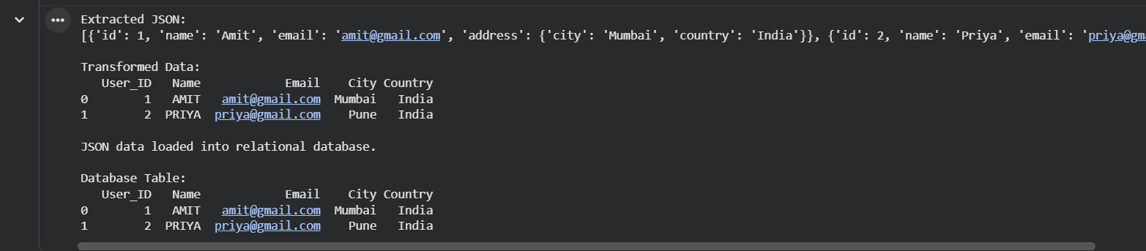

4: ETL Process to Identify and Remove Invalid Records
Aim: Design an ETL process to identify and remove invalid records before loading them into the database.
Code:
import pandas as pd
import sqlite3

# -----------------------------
# EXTRACT
# -----------------------------

data = {
"ID": [1, 2, 3, 4, 5],
"Name": ["Amit", "Priya", "", "Rahul", "Sneha"],
"Age": [21, -5, 25, 200, 23],
"Email": [
"amit@gmail.com",
"priya@gmail.com",
"invalidemail",
"rahul@gmail.com",
"sneha@gmail.com"
]
}

df = pd.DataFrame(data)

print("Original Data:")
print(df)

# -----------------------------
# IDENTIFY INVALID RECORDS
# -----------------------------

invalid = (
(df["Name"] == "") |
(df["Age"] < 0) |
(df["Age"] > 120) |
(~df["Email"].str.contains("@", na=False))
)

invalid_records = df[invalid]

print("\nInvalid Records:")
print(invalid_records)

# -----------------------------
# REMOVE INVALID RECORDS
# -----------------------------

clean_df = df[~invalid].copy()

print("\nClean Data:")
print(clean_df)

# -----------------------------
# LOAD
# -----------------------------

conn = sqlite3.connect("valid_data.db")

clean_df.to_sql(
"valid_users",
conn,
if_exists="replace",
index=False
)

print("\nValid records loaded successfully.")

conn.close()

Expected Output

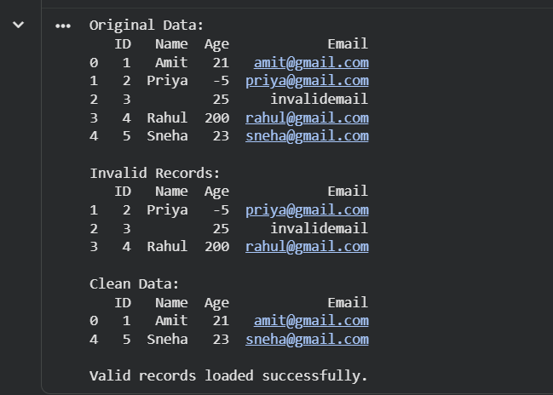

5: Data Validation Before Loading
Aim: Create a pipeline that performs data validation before loading data into the target database.
Code:
import pandas as pd
import sqlite3

# -----------------------------
# EXTRACT
# -----------------------------

data = {
"ID": [1, 2, 3, 4],
"Name": ["Amit", "Priya", "Rahul", "Sneha"],
"Age": [21, 22, 150, 24],
"Email": [
"amit@gmail.com",
"priya@gmail.com",
"rahul@gmail.com",
"invalid-email"
]
}

df = pd.DataFrame(data)

print("Extracted Data:")
print(df)

# -----------------------------
# VALIDATION
# -----------------------------

def validate_record(row):

if row["Age"] < 18 or row["Age"] > 100:
return False

if "@" not in row["Email"]:
return False

if row["Name"] == "":
return False

return True

df["Valid"] = df.apply(validate_record, axis=1)

print("\nValidation Results:")
print(df)

# Separate valid and invalid records
valid_df = df[df["Valid"] == True].drop(columns=["Valid"])
invalid_df = df[df["Valid"] == False].drop(columns=["Valid"])

print("\nValid Records:")
print(valid_df)

print("\nInvalid Records:")
print(invalid_df)

# -----------------------------
# LOAD ONLY VALID DATA
# -----------------------------

conn = sqlite3.connect("validated_database.db")

valid_df.to_sql(
"customers",
conn,
if_exists="replace",
index=False
)

print("\nValidated data loaded successfully.")

conn.close()

Expected Output

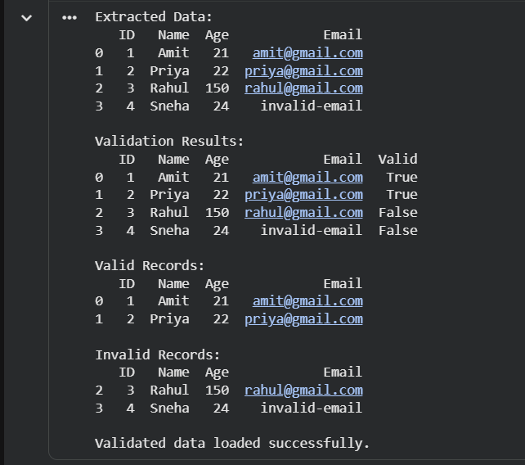
Only valid records are loaded into the target database.

6: Incremental Data Loading
Aim: Implement incremental data loading instead of loading the entire dataset every time.
Code:
import pandas as pd
df_initial.to_csv("employees_initial.csv", index=False)

# -----------------------------
# CREATE DATABASE
# -----------------------------

conn = sqlite3.connect("incremental_database.db")

df_initial.to_sql(
"employees",
conn,
if_exists="replace",
index=False
)

print("Initial data loaded:")
print(df_initial)

# -----------------------------
# NEW DATA
# -----------------------------

new_data = {
"ID": [4, 5],
"Name": ["Sneha", "Karan"],
"Salary": [42000, 45000]
}

df_new = pd.DataFrame(new_data)

df_new.to_csv("employees_new.csv", index=False)

print("\nNew data:")
print(df_new)

# -----------------------------
# CHECK EXISTING RECORDS
# -----------------------------

existing_df = pd.read_sql(
"SELECT ID FROM employees",
conn
)

print("\nExisting IDs:")
print(existing_df)

# -----------------------------
# INCREMENTAL LOAD
# -----------------------------

incremental_df = df_new[
~df_new["ID"].isin(existing_df["ID"])
]

if not incremental_df.empty:

incremental_df.to_sql(
"employees",
conn,
if_exists="append",
index=False
)

print("\nNew records inserted:")
print(incremental_df)

else:
print("\nNo new records found.")

# -----------------------------
# FINAL DATABASE
# -----------------------------

final_df = pd.read_sql(
"SELECT * FROM employees",
conn
)

print("\nFinal Database:")
print(final_df)

conn.close()

Expected Output

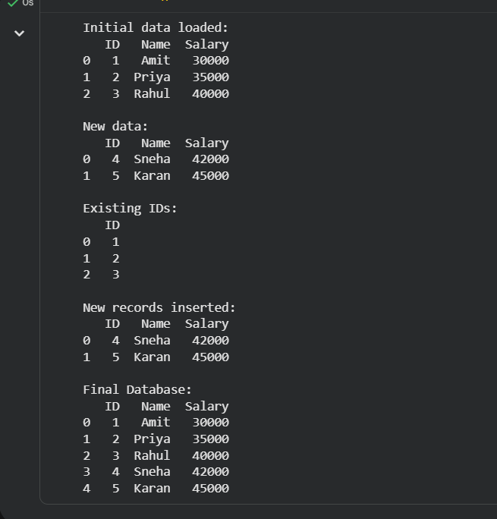

ETL Flow for all practicals
Source Data
↓
Extract
(CSV / Multiple CSV / JSON)
↓
Clean & Validate
↓
Transform
(Filter / Format / Calculate)
↓
Load
(SQLite Database)
↓
Target Database
These practicals cover CSV extraction, multiple-file merging, JSON ETL, invalid-record removal, data validation, and incremental loading using one simple Python-based ETL environment.

Practical : 8

Aim
No separate Aim is written in the uploaded notebook.
The practical is implemented using PySpark for sales-data processing and analysis, including CSV loading, filtering, grouping, duplicate removal, joining datasets, and average-sales analysis.

Code
# Data Engineering Practicals
# Practical-8

# Install PySpark
!pip install pyspark
from pyspark.sql import SparkSession
from pyspark.sql.functions import col, avg, sum, count
spark = SparkSession.builder \
.appName("PySpark Assignment") \
.getOrCreate()

print("Spark started successfully!")
%%writefile sales.csv
Product,Category,Sales,Quantity
Laptop,Electronics,1000,2
Phone,Electronics,500,5
Chair,Furniture,200,4
Table,Furniture,300,2
Laptop,Electronics,1000,2
Headphones,Electronics,150,10
Chair,Furniture,200,4
Book,Stationery,50,20
df = spark.read.csv("sales.csv", header=True, inferSchema=True)

df.show()

print("Schema:")
df.printSchema()
filtered_df = df.filter(col("Sales") > 500)

filtered_df.show()
df.filter(df.Sales > 500).show()
grouped_df = df.groupBy("Category").agg(
sum("Sales").alias("Total_Sales")
)

grouped_df.show()
grouped_df = df.groupBy("Category").sum("Sales")

grouped_df.show()
from pyspark.sql import SparkSession
from pyspark.sql.functions import col, avg, sum

spark = SparkSession.builder \
.appName("Sales Analysis") \
.getOrCreate()

df = spark.read.csv(
"sales.csv",
header=True,
inferSchema=True
)

df.show()
from pyspark.sql.functions import sum

df.groupBy("Category").agg(
sum("Sales").alias("Total_Sales")
).show()
df.dropDuplicates().show()
from pyspark.sql.functions import sum, avg

grouped_df = df.groupBy("Category").agg(
sum("Sales").alias("Total_Sales")
)

print("Total Sales by Category:")
grouped_df.show()
deduplicated_df = df.dropDuplicates()

print("Dataset after removing duplicates:")
deduplicated_df.show()
%%writefile product_info.csv
Product,Brand
Laptop,Dell
Phone,Samsung
Chair,IKEA
Table,IKEA
Headphones,Sony
Book,Penguin
product_df = spark.read.csv(
"product_info.csv",
header=True,
inferSchema=True
)

product_df.show()
joined_df = df.join(
product_df,
on="Product",
how="inner"
)

print("Joined Dataset:")
joined_df.show()
average_sales = df.groupBy("Category").agg(
avg("Sales").alias("Average_Sales")
)

print("Average Sales by Product Category:")
average_sales.show()

Output
The actual notebook outputs include:

Spark started

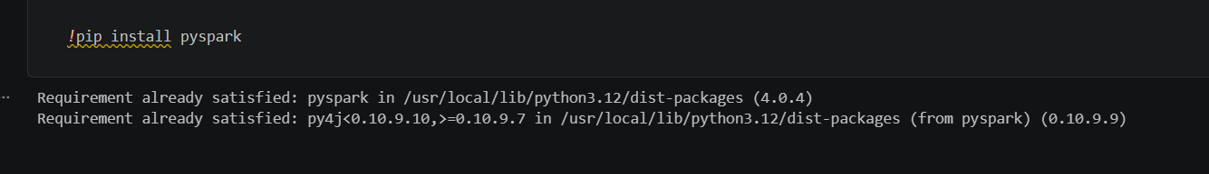
Spark started successfully!

Sales CSV and Schema

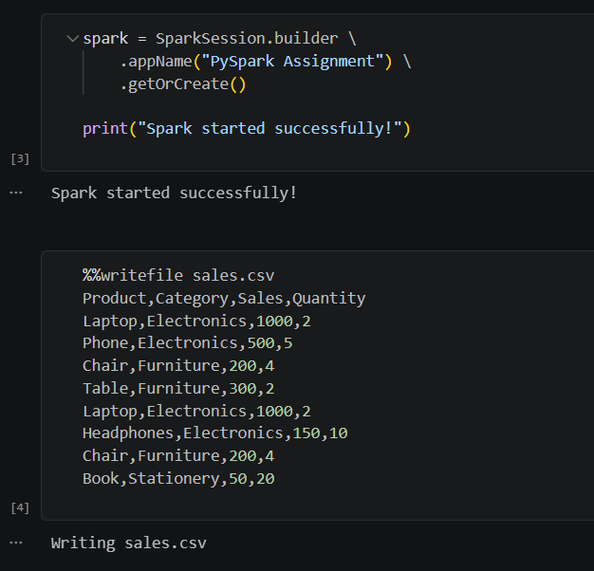

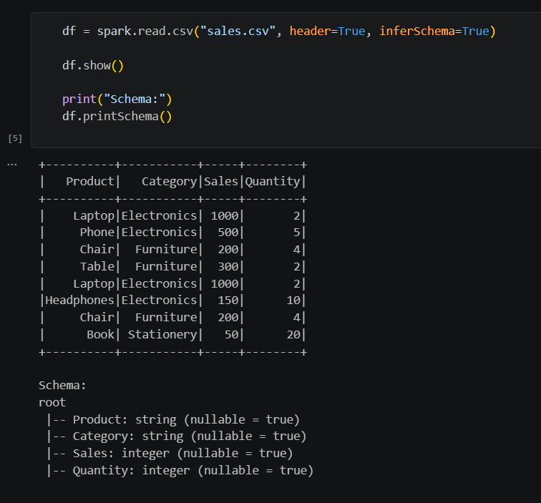

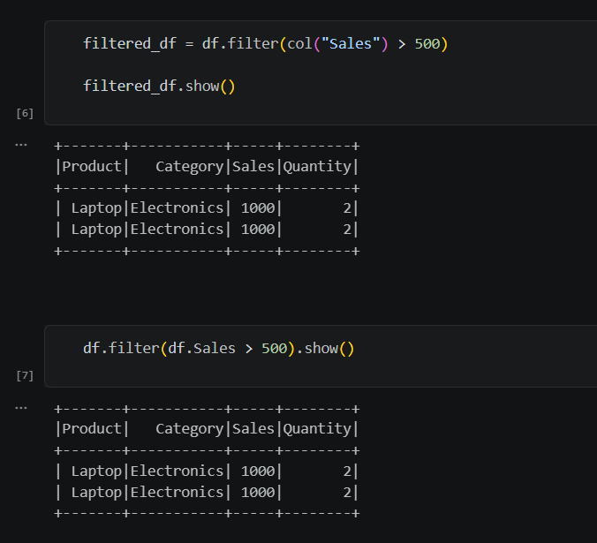

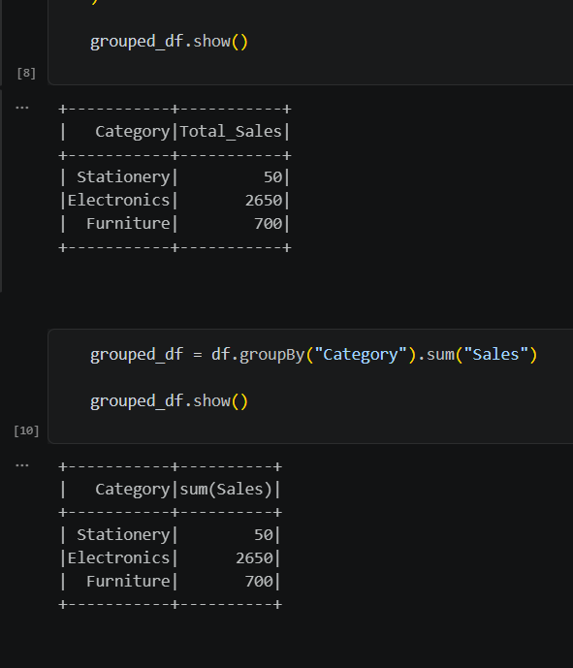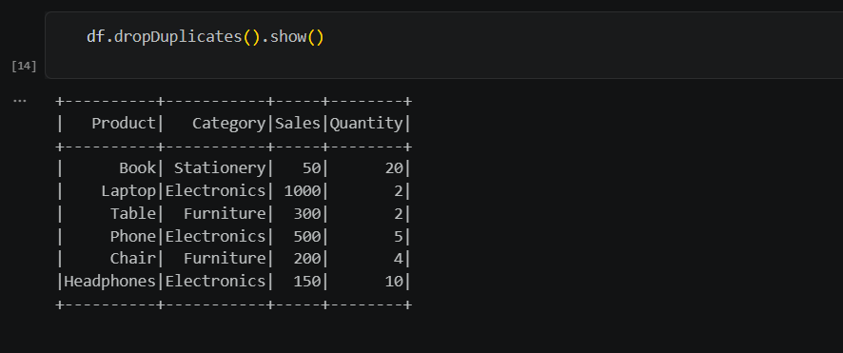

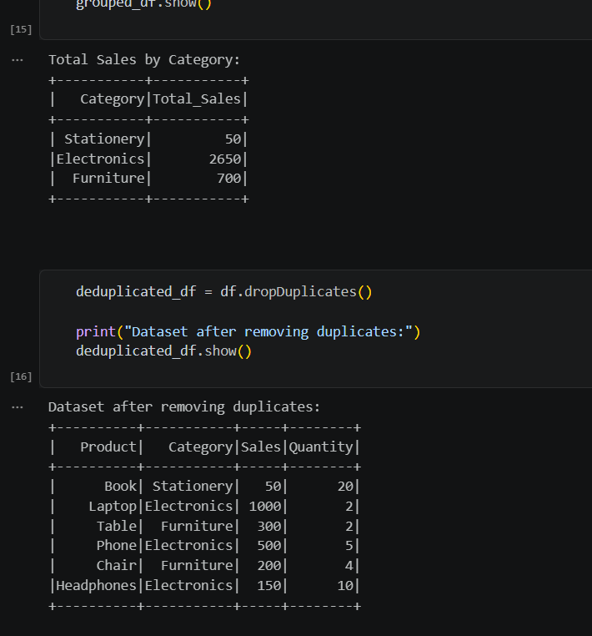

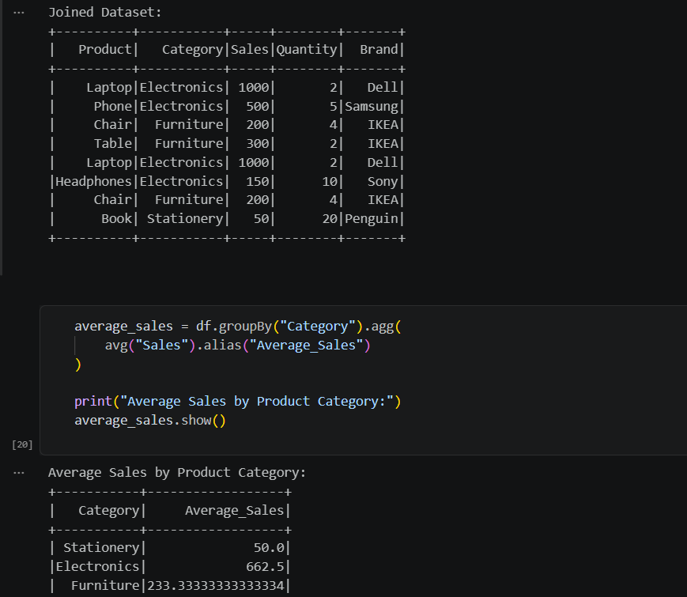
PRACTICAL-9
End-to-End Data Engineering Pipeline

Aim
To build an ETL pipeline for an e-commerce dataset containing customers, orders, products, and payments, and to design a data pipeline that handles both historical and newly arriving data.

Code
# Data Engineering Practicals
# Practical-9
# Name: Insiya Shoeb Bobde
# Rollno: 06
# Student-id: 5115304
import pandas as pd
data = {
"Customer": ["John", "Mary", "John", "David", None],
"Product": ["Laptop", "Phone", "Laptop", "Tablet", "Phone"],
"Sales": [1000, 500, 1000, 700, None],
"Quantity": [1, 2, 1, 3, 2]
}
df = pd.DataFrame(data)
df.to_csv("sales_data.csv", index=False)
print("CSV created successfully!")
df
df = pd.read_csv("sales_data.csv")
print("Original Data:")
print(df)
print("Missing values:")
print(df.isnull().sum())
df["Customer"] = df["Customer"].fillna("Unknown")
df["Sales"] = df["Sales"].fillna(df["Sales"].mean())
print("Cleaned Data:")
print(df)
df = df.drop_duplicates()
print("After removing duplicates:")
print(df)
import sqlite3
connection = sqlite3.connect("sales_database.db")
df.to_sql(
"sales",
connection,
if_exists="replace",
index=False
)
print("Data stored in SQL database successfully!")
query = """
SELECT Product, SUM(Sales) AS Total_Sales
FROM sales
GROUP BY Product
"""
report = pd.read_sql_query(query, connection)
print("Sales Report:")
print(report)
connection.close()
print("Pipeline completed successfully!")
import pandas as pd
customers = pd.DataFrame({
"customer_id": [1, 2, 3],
"name": ["John", "Mary", "David"],
"email": ["john@gmail.com", "mary@gmail.com", "david@gmail.com"]
})
products = pd.DataFrame({
"product_id": [101, 102, 103],
"product": ["Laptop", "Phone", "Tablet"],
"price": [1000, 500, 700]
})
orders = pd.DataFrame({
"order_id": [1001, 1002, 1003],
"customer_id": [1, 2, 3],
"product_id": [101, 102, 103],
"quantity": [1, 2, 1]
})
payments = pd.DataFrame({
"payment_id": [501, 502, 503],
"order_id": [1001, 1002, 1003],
"payment_status": ["Paid", "Paid", "Pending"]
})
print("Data extracted successfully!")
order_data = orders.merge(
products,
on="product_id"
)
order_data["total_amount"] = (
order_data["price"] * order_data["quantity"]
)
print("Transformed Order Data:")
print(order_data)
order_data = order_data.merge(
customers,
on="customer_id"
)
print("Customer + Order Data:")
print(order_data)
order_data = order_data.merge(
payments,
on="order_id"
)
print("Complete E-commerce Data:")
print(order_data)
import sqlite3
connection = sqlite3.connect("ecommerce.db")
customers.to_sql(
"customers",
connection,
if_exists="replace",
index=False
)
products.to_sql(
"products",
connection,
if_exists="replace",
index=False
)
orders.to_sql(
"orders",
connection,
if_exists="replace",
index=False
)
payments.to_sql(
"payments",
connection,
if_exists="replace",
index=False
)
order_data.to_sql(
"order_report",
connection,
if_exists="replace",
index=False
)
print("ETL pipeline completed!")
query = """
SELECT product,
SUM(quantity) AS total_quantity,
SUM(total_amount) AS total_sales
FROM order_report
GROUP BY product
"""
report = pd.read_sql_query(query, connection)
print("E-commerce Sales Report:")
print(report)
connection.close()
import pandas as pd
historical_data = pd.DataFrame({
"order_id": [1, 2, 3],
"customer": ["John", "Mary", "David"],
"sales": [1000, 500, 700]
})
historical_data
new_data = pd.DataFrame({
"order_id": [4, 5],
"customer": ["Alice", "Bob"],
"sales": [800, 600]
})
new_data
combined_data = pd.concat(
[historical_data, new_data],
ignore_index=True
)
print("Combined Data:")
print(combined_data)
combined_data = combined_data.drop_duplicates(
subset=["order_id"]
)
print("Data after removing duplicates:")
print(combined_data)
import sqlite3
connection = sqlite3.connect("historical_new_data.db")
combined_data.to_sql(
"orders",
connection,
if_exists="replace",
index=False
)
print("Historical and new data loaded into database!")
query = """
SELECT customer,
SUM(sales) AS total_sales
FROM orders
GROUP BY customer
"""
final_report = pd.read_sql_query(
query,
connection
)
print("Final Report:")
print(final_report)
connection.close()
print("Historical + New Data Pipeline Completed!")

Output
Output
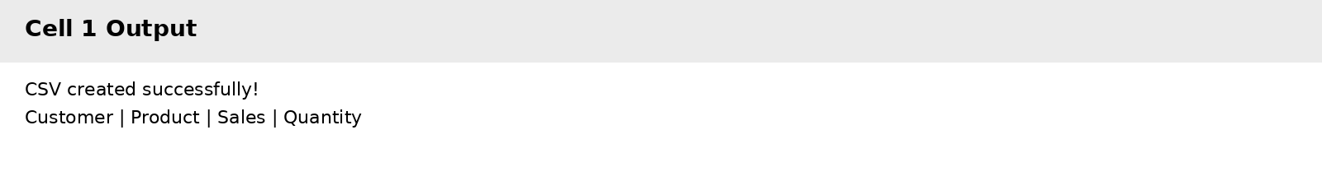

Output
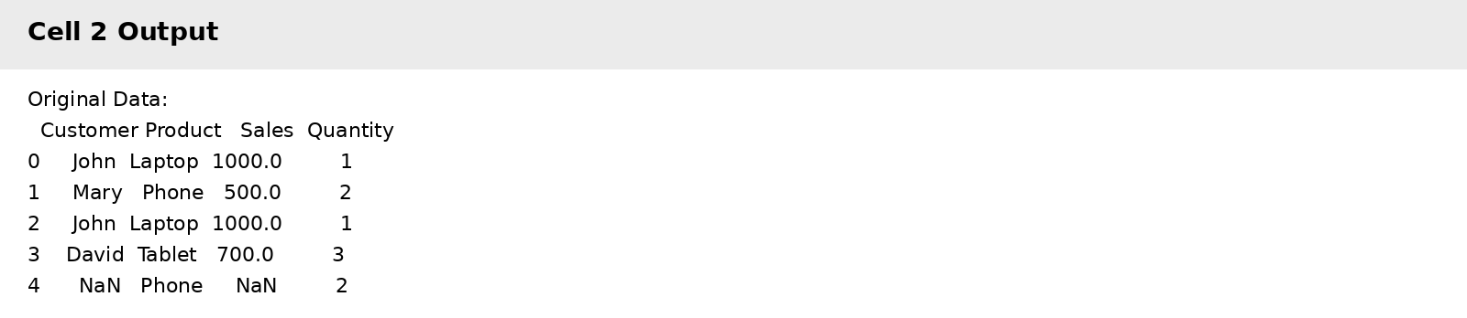

Output
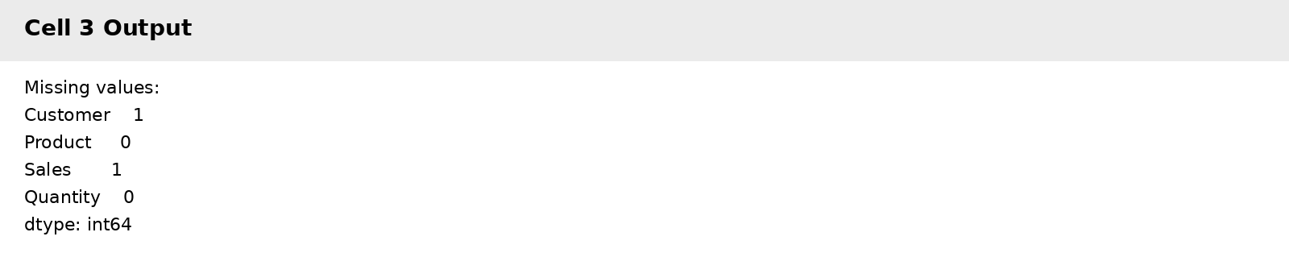

Output 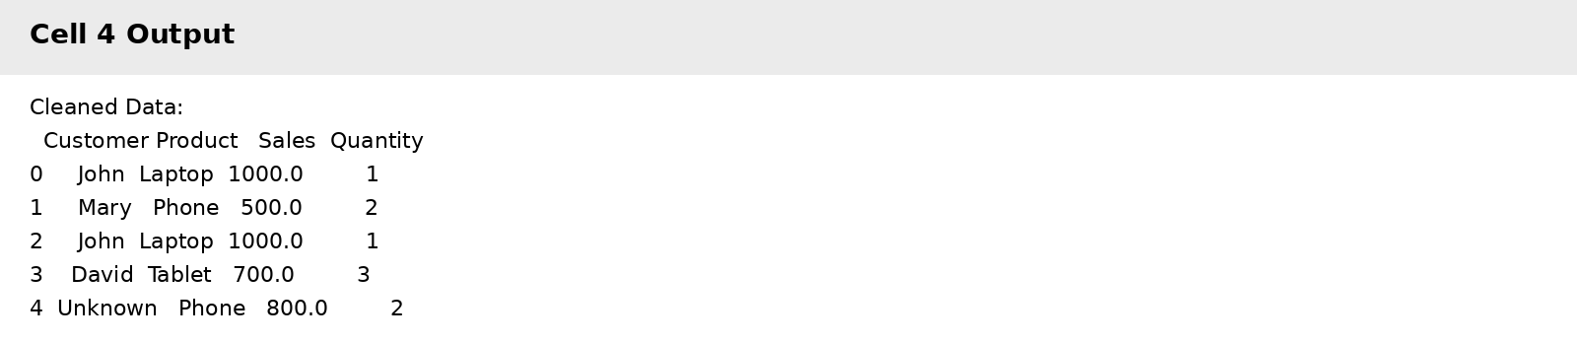

Output
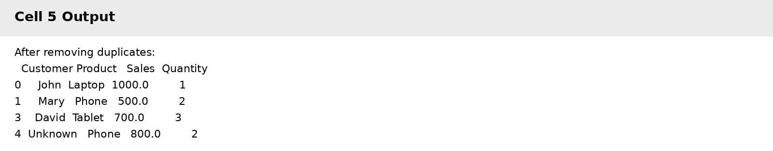

Output
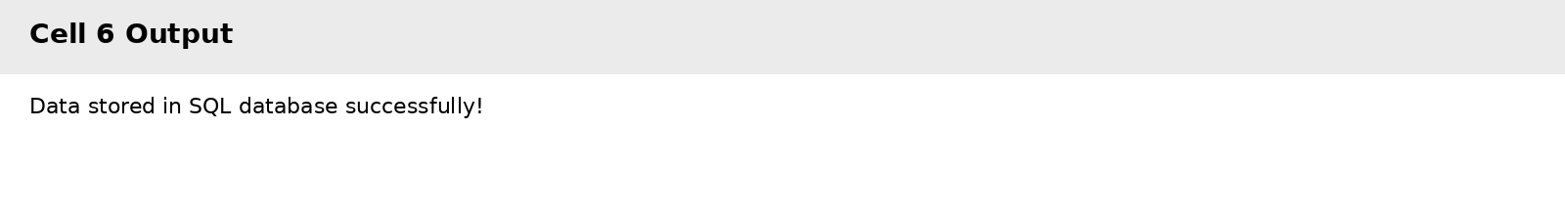

Output
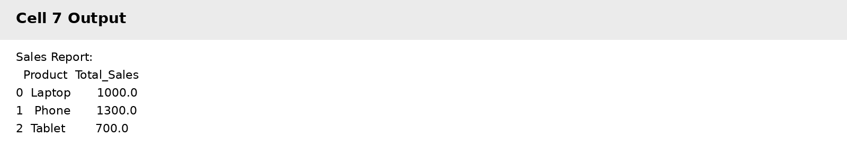

Output
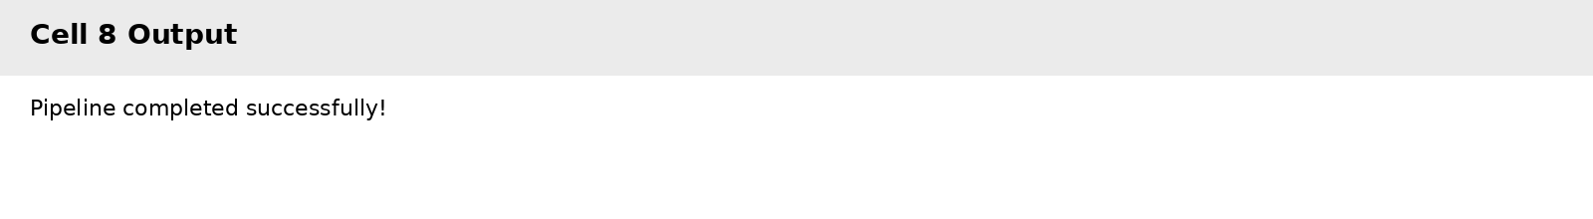

Output
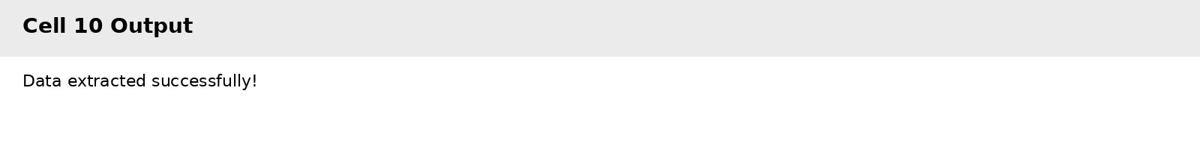

Output 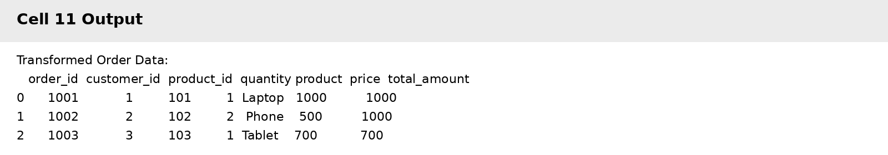

Output
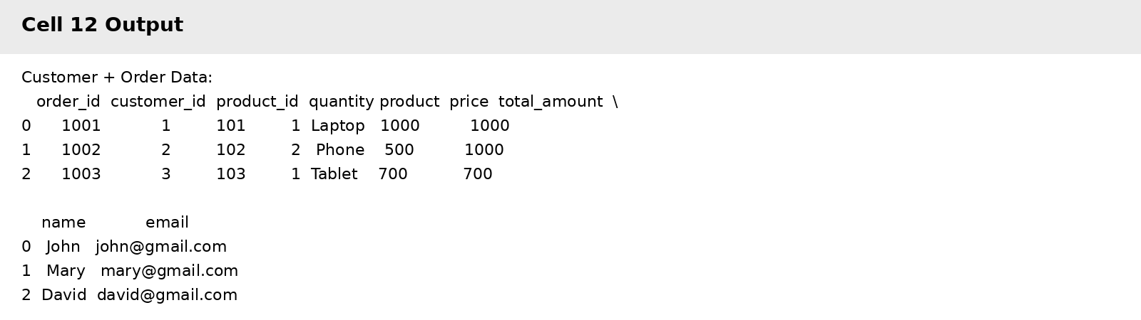

Output
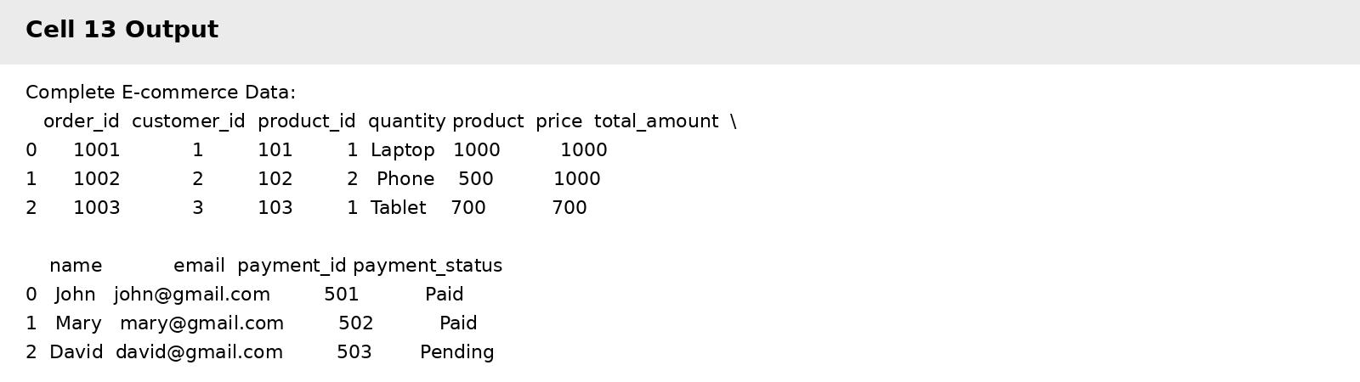

Output
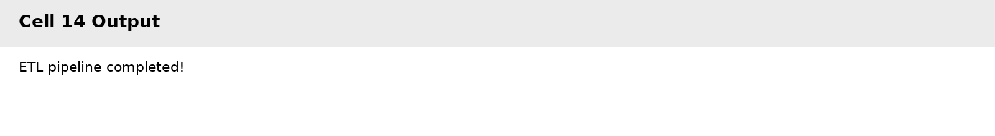

Output 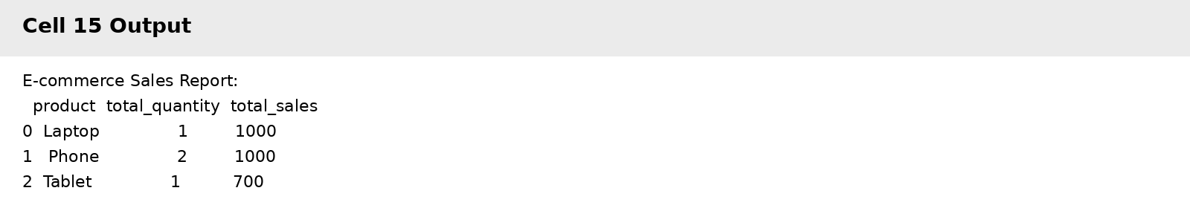

Output
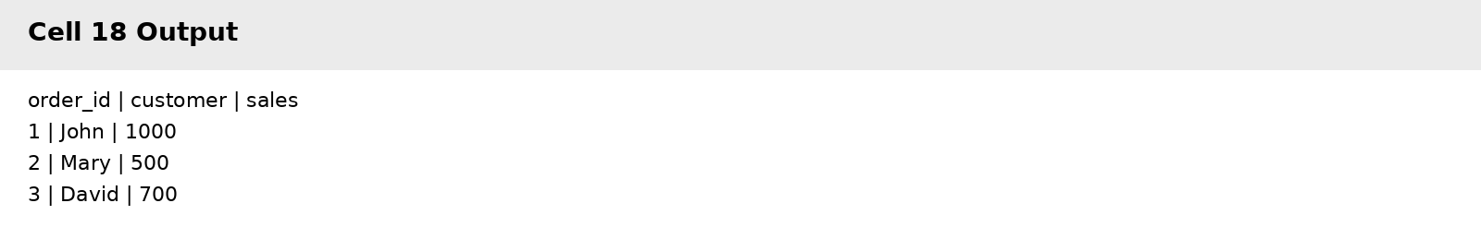

Output
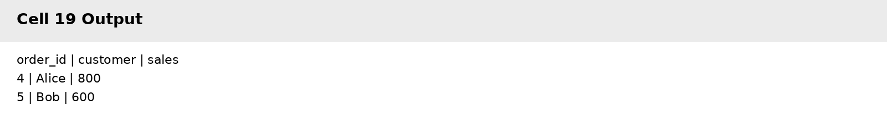

Output
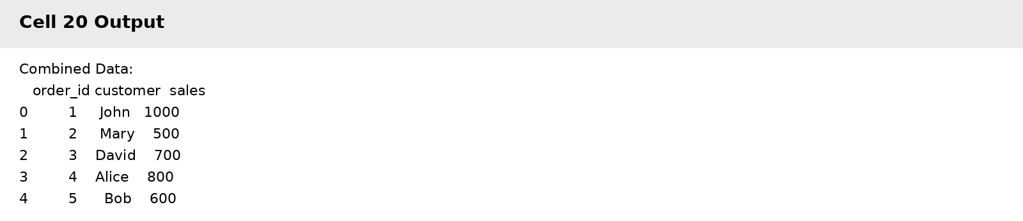

Output
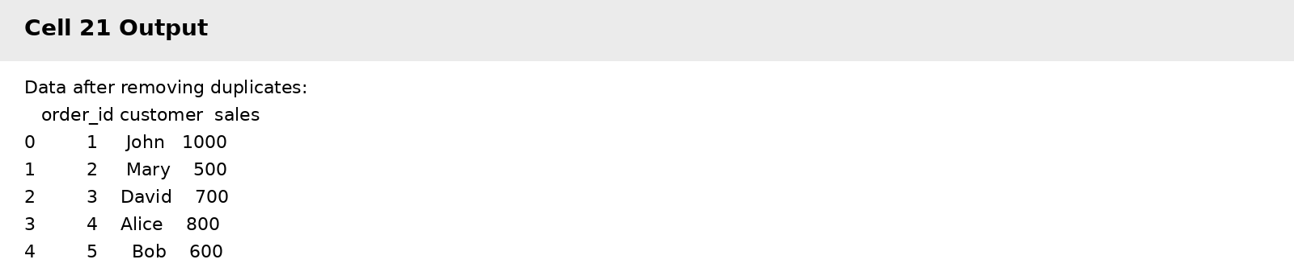

Output
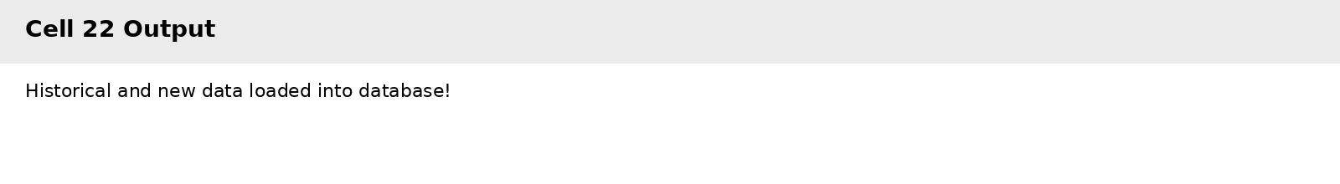

Output
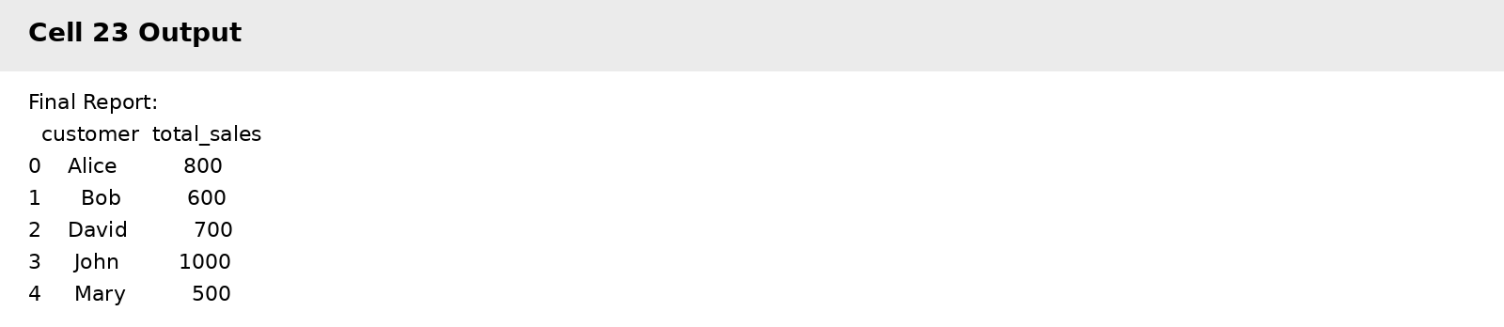

Output 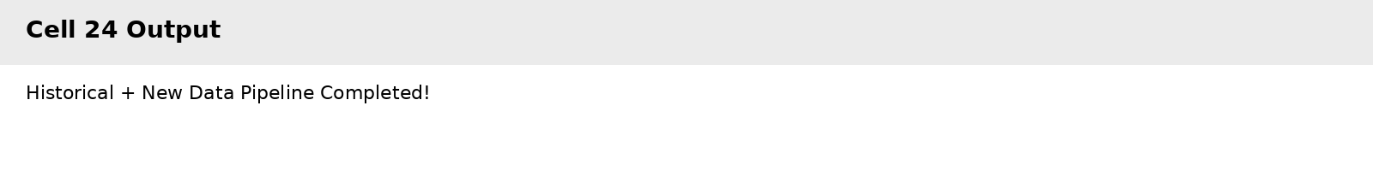

Result
The ETL pipeline was successfully implemented. The e-commerce data was extracted, transformed by joining customers, products, orders and payments, stored in an SQLite database, and used to generate a sales report. Historical and newly arriving data were combined, duplicates were handled, the combined data was stored, and a final customer-wise sales report was generated.

PRACTICAL-10
Question
Mini Project: Design and implement an end-to-end data engineering solution including data ingestion, cleaning, transformation, storage, data warehouse design, and reporting.
Aim
To design and implement an end-to-end data engineering solution covering data ingestion, cleaning, transformation, storage, data warehouse design, and reporting.
Code
import pandas as pd
# Customers
customers = pd.DataFrame({
"customer_id": [1, 2, 3, 4, 5],
"customer_name": ["John", "Mary", "David", "Alice", "Bob"],
"city": ["Mumbai", "Delhi", "Pune", "Mumbai", "Chennai"]
})
# Products
products = pd.DataFrame({
"product_id": [101, 102, 103, 104, 105],
"product_name": ["Laptop", "Phone", "Tablet", "Headphones", "Keyboard"],
"category": ["Electronics", "Electronics", "Electronics", "Accessories", "Accessories"],
"price": [60000, 30000, 20000, 3000, 1500]
})
# Orders
orders = pd.DataFrame({
"order_id": [1001, 1002, 1003, 1004, 1005],
"customer_id": [1, 2, 3, 4, 5],
"product_id": [101, 102, 103, 104, 105],
"quantity": [1, 2, 1, 3, 2]
})
# Payments
payments = pd.DataFrame({
"payment_id": [501, 502, 503, 504, 505],
"order_id": [1001, 1002, 1003, 1004, 1005],
"payment_status": ["Paid", "Paid", "Paid", "Pending", "Paid"]
})
print("Customers:")
display(customers)
print("Products:")
display(products)
print("Orders:")
display(orders)
print("Payments:")
display(payments)
customers.to_csv("customers.csv", index=False)
products.to_csv("products.csv", index=False)
orders.to_csv("orders.csv", index=False)
payments.to_csv("payments.csv", index=False)
print("All CSV files created successfully!")
# Check for missing values
print("Missing values in Customers:")
print(customers.isnull().sum())
print("\nMissing values in Products:")
print(products.isnull().sum())
print("\nMissing values in Orders:")
print(orders.isnull().sum())
print("\nMissing values in Payments:")
print(payments.isnull().sum())
# Check for missing values
print("Missing values in Customers:")
print(customers.isnull().sum())
print("\nMissing values in Products:")
print(products.isnull().sum())
print("\nMissing values in Orders:")
print(orders.isnull().sum())
print("\nMissing values in Payments:")
print(payments.isnull().sum())
# Remove duplicate records
customers = customers.drop_duplicates()
products = products.drop_duplicates()
orders = orders.drop_duplicates()
payments = payments.drop_duplicates()
print("Duplicates removed successfully!")
print("Customers data types:")
print(customers.dtypes)
print("\nProducts data types:")
print(products.dtypes)
print("\nOrders data types:")
print(orders.dtypes)
print("\nPayments data types:")
print(payments.dtypes)
print("Cleaned Customers:")
display(customers)
print("Cleaned Products:")
display(products)
print("Cleaned Orders:")
display(orders)
print("Cleaned Payments:")
display(payments)
order_data = orders.merge(
products,
on="product_id",
how="inner"
)
print("Orders + Products:")
display(order_data)
order_data["total_sales"] = (
order_data["price"] * order_data["quantity"]
)
print("Total Sales Calculated:")
display(order_data)
order_data = order_data.merge(
customers,
on="customer_id",
how="inner"
)
print("Added Customer Information:")
display(order_data)
order_data = order_data.merge(
payments,
on="order_id",
how="inner"
)
print("Final Transformed Dataset:")
display(order_data)
sales_summary = order_data.groupby("category").agg(
total_sales=("total_sales", "sum"),
total_quantity=("quantity", "sum")
).reset_index()
print("Sales Summary by Category:")
display(sales_summary)
import sqlite3
# Create SQLite database
connection = sqlite3.connect("ecommerce_warehouse.db")
print("Database created successfully!")
customers.to_sql(
"dim_customer",
connection,
if_exists="replace",
index=False
)
products.to_sql(
"dim_product",
connection,
if_exists="replace",
index=False
)
orders.to_sql(
"orders",
connection,
if_exists="replace",
index=False
)
payments.to_sql(
"payments",
connection,
if_exists="replace",
index=False
)
order_data.to_sql(
"fact_sales",
connection,
if_exists="replace",
index=False
)
print("All tables stored in the database!")
print("Customer Dimension:")
display(pd.read_sql_query(
"SELECT * FROM dim_customer",
connection
))
print("Product Dimension:")
display(pd.read_sql_query(
"SELECT * FROM dim_product",
connection
))
print("Fact Sales:")
display(pd.read_sql_query(
"SELECT * FROM fact_sales",
connection
))
tables = pd.read_sql_query(
"SELECT name FROM sqlite_master WHERE type='table'",
connection
)
print("Tables in Data Warehouse:")
display(tables)
date_data = pd.DataFrame({
"date_id": [1, 2, 3, 4, 5],
"date": [
"2026-01-01",
"2026-01-02",
"2026-01-03",
"2026-01-04",
"2026-01-05"
],
"year": [2026, 2026, 2026, 2026, 2026],
"month": [1, 1, 1, 1, 1]
})
display(date_data)
date_data.to_sql(
"dim_date",
connection,
if_exists="replace",
index=False
)
print("Date dimension created!")
query = """
SELECT SUM(total_sales) AS total_sales
FROM fact_sales
"""
total_sales_report = pd.read_sql_query(
query,
connection
)
print("Total Sales:")
display(total_sales_report)
query = """
SELECT category,
SUM(total_sales) AS total_sales
FROM fact_sales
GROUP BY category
"""
category_report = pd.read_sql_query(
query,
connection
)
print("Sales by Category:")
display(category_report)
query = """
SELECT customer_name,
SUM(total_sales) AS total_sales
FROM fact_sales
GROUP BY customer_name
"""
customer_report = pd.read_sql_query(
query,
connection
)
print("Sales by Customer:")
display(customer_report)
query = """
SELECT payment_status,
COUNT(*) AS number_of_orders,
SUM(total_sales) AS total_sales
FROM fact_sales
GROUP BY payment_status
"""
payment_report = pd.read_sql_query(
query,
connection
)
print("Payment Report:")
display(payment_report)
import matplotlib.pyplot as plt
plt.figure(figsize=(8, 5))
plt.bar(
category_report["category"],
category_report["total_sales"]
)
plt.title("Sales by Product Category")
plt.xlabel("Category")
plt.ylabel("Total Sales")
plt.show()
print("====================================")
print("END-TO-END DATA ENGINEERING PROJECT")
print("====================================")
print("✓ Data Ingestion")
print("✓ Data Cleaning")
print("✓ Data Transformation")
print("✓ SQL Storage")
print("✓ Data Warehouse Design")
print("✓ Reporting")
print("✓ Visualization")
print("\nPROJECT COMPLETED SUCCESSFULLY!")
connection.close()

Output Screenshots
Output
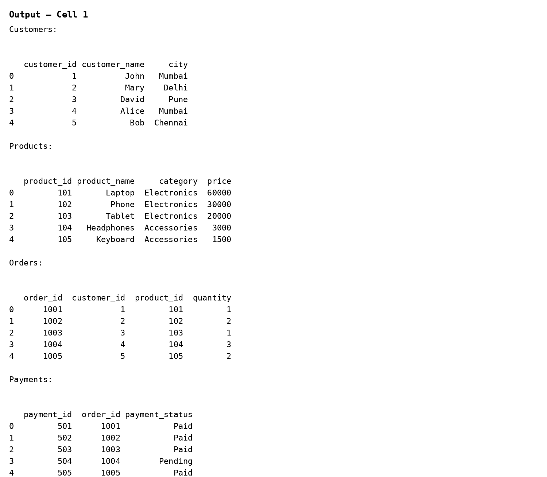
Output
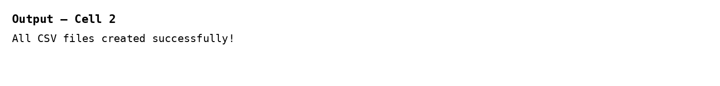
Output
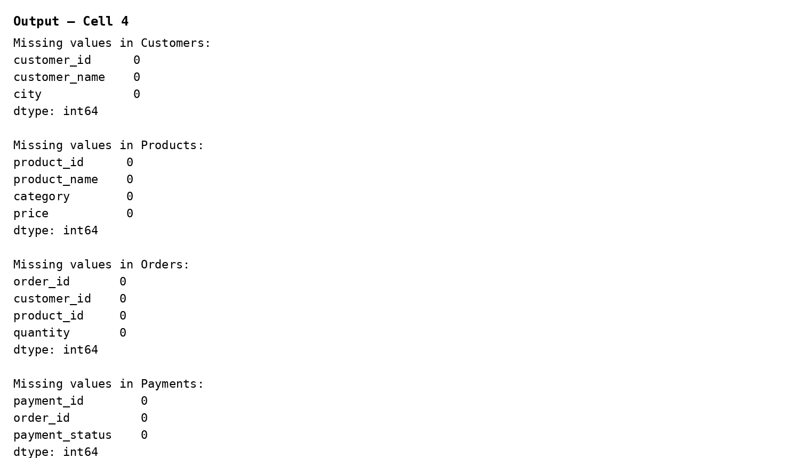
Output
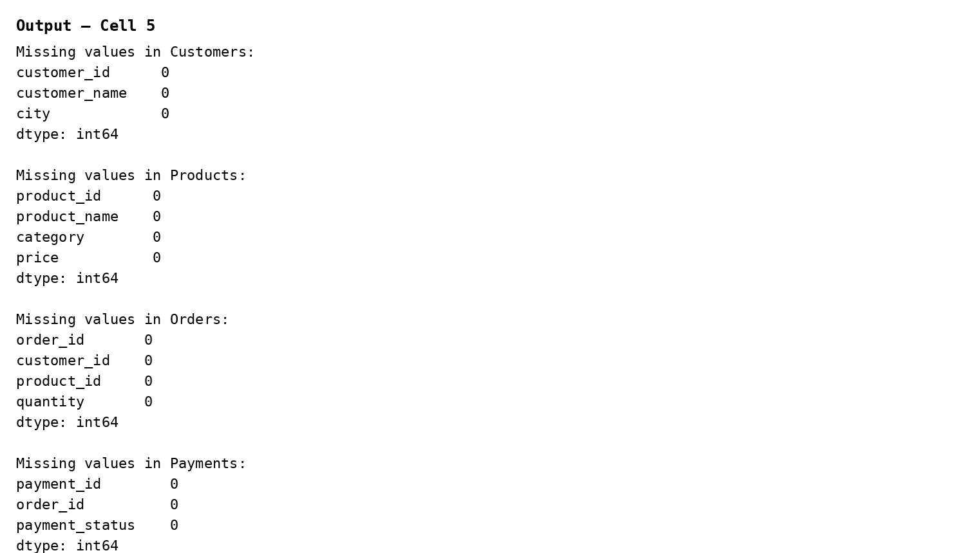

Output
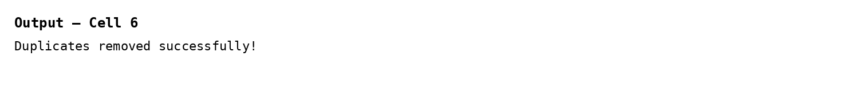
Output
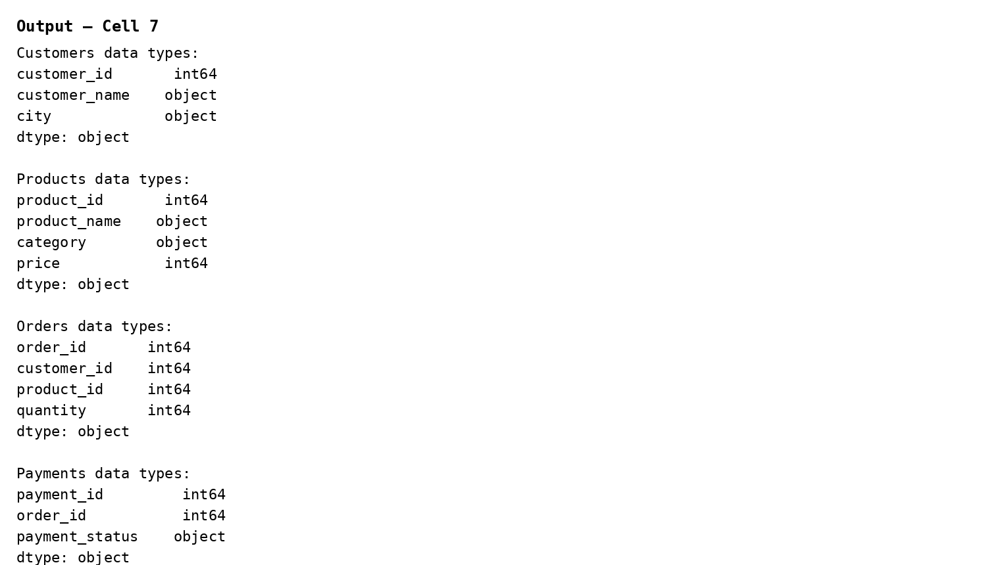

Output
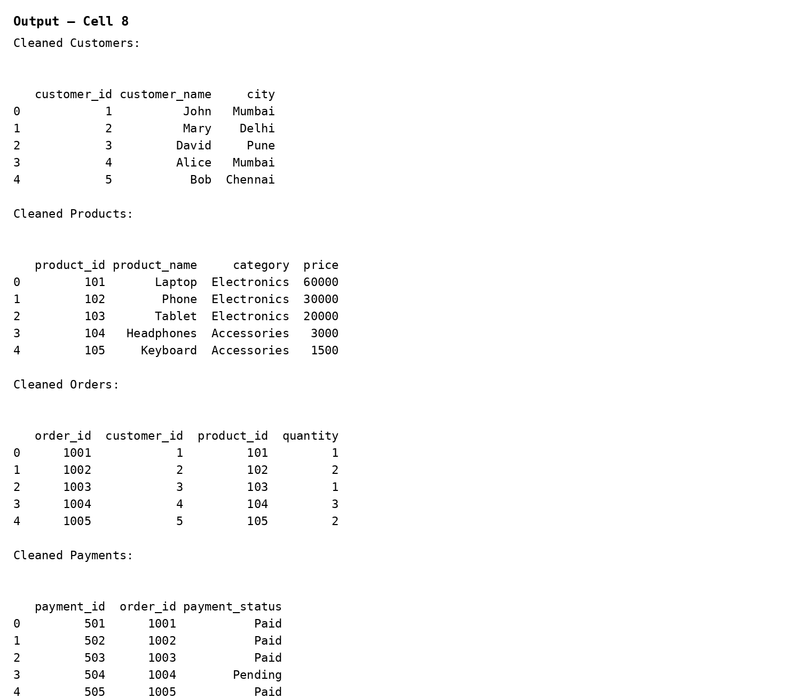
Output
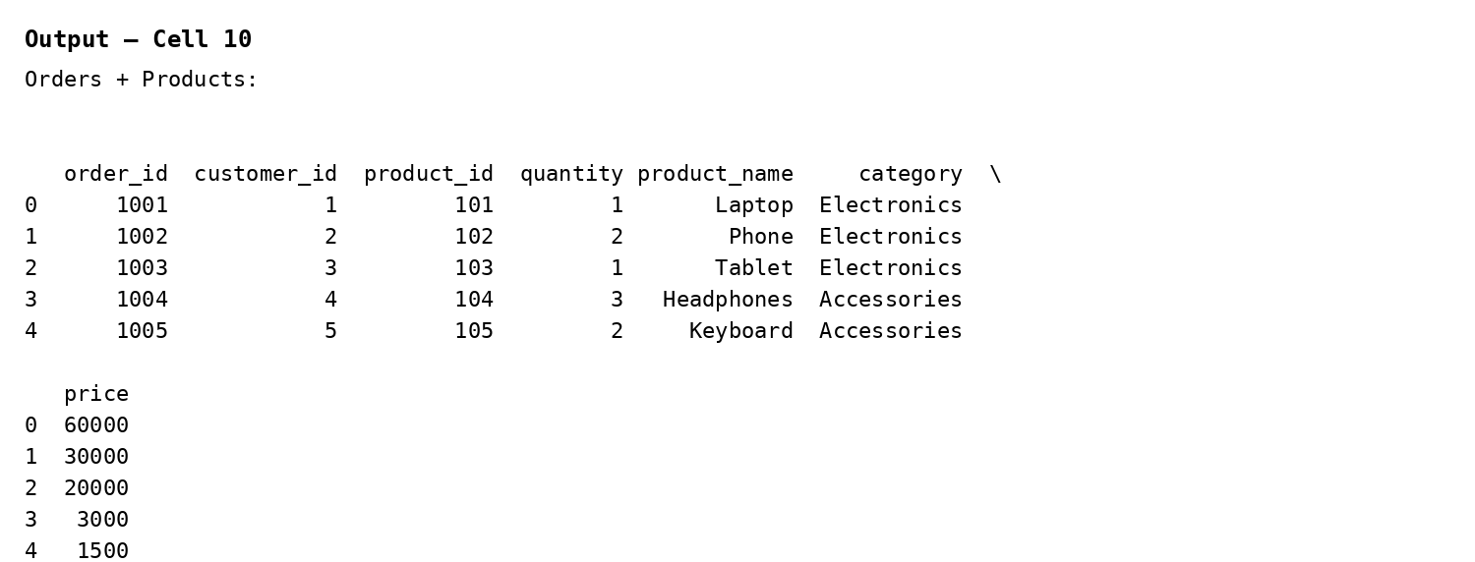

Output
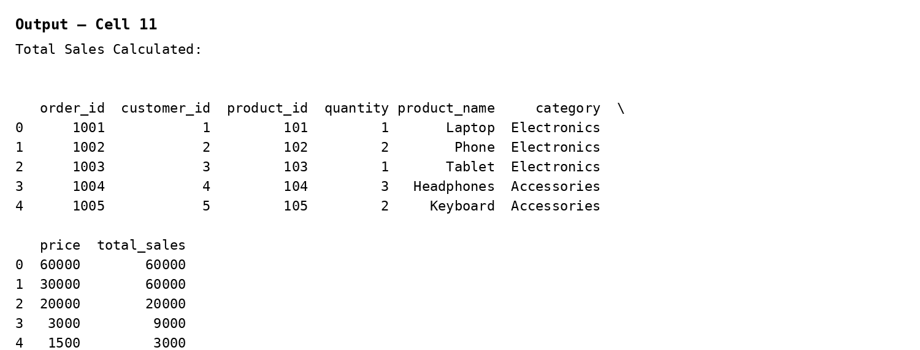
Output
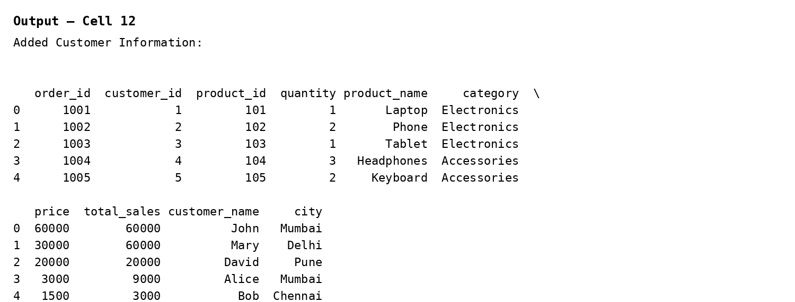
Output 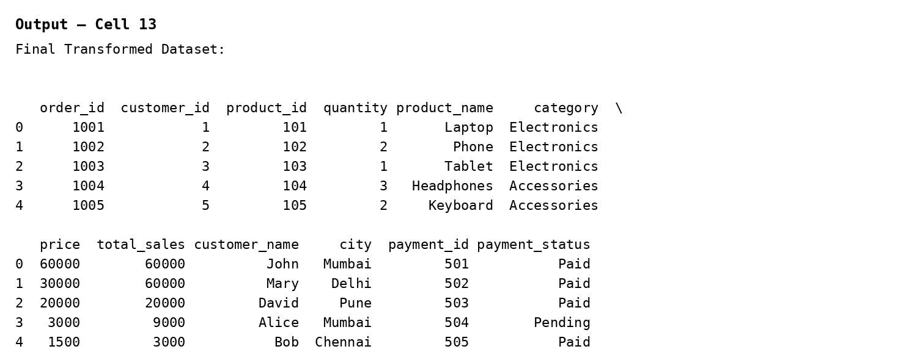

Output
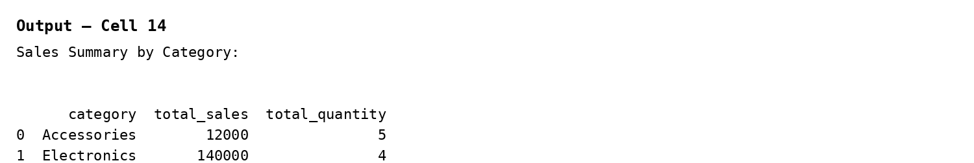
Output
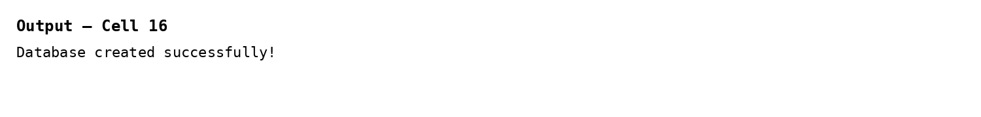
Output 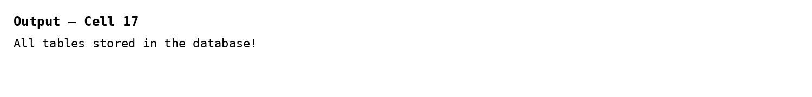Output 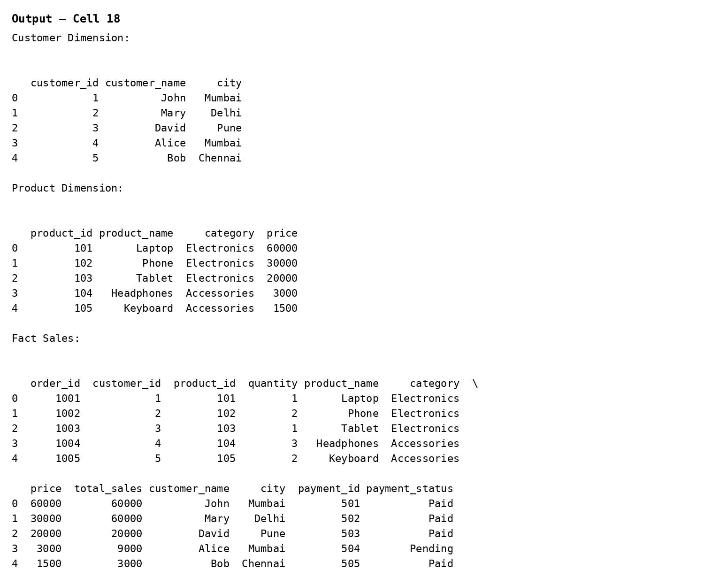

Output S
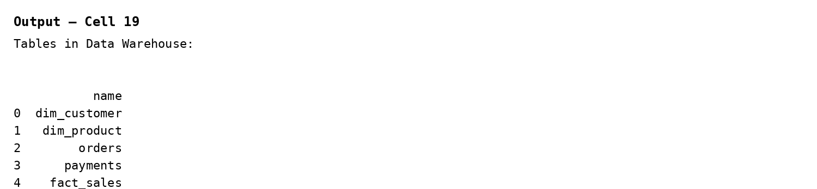
Output
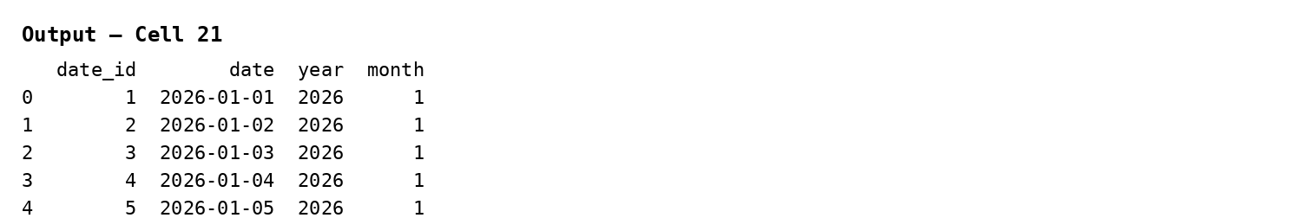
Output
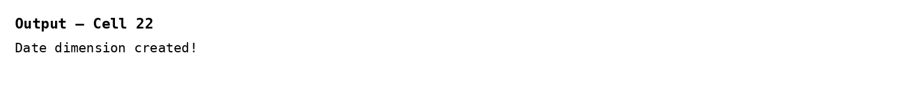
Output
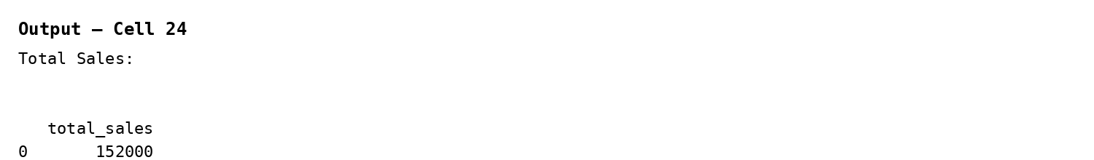
Output
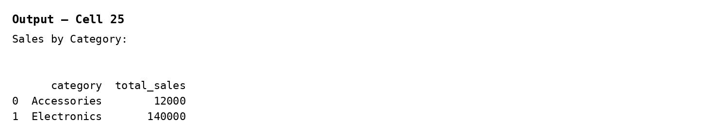Output 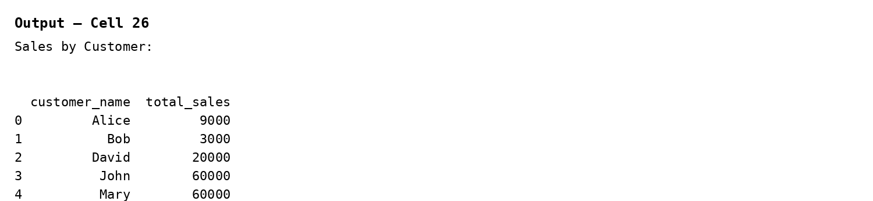
Output
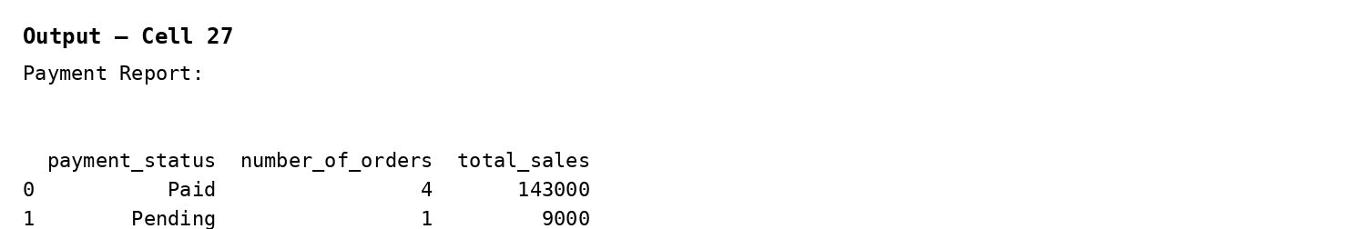
Output
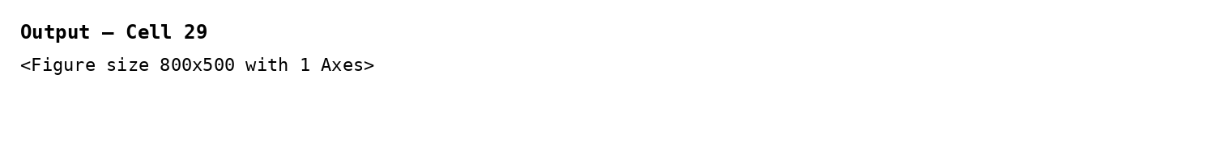
Output
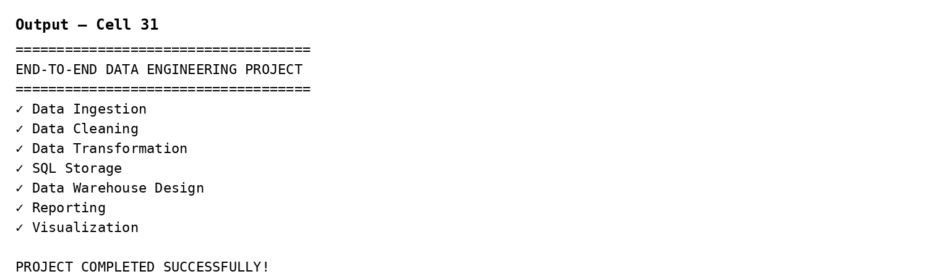
Result
The end-to-end data engineering solution was implemented successfully, covering ingestion, cleaning, transformation, storage, warehouse design, and reporting as demonstrated by the notebook outputs.

